1

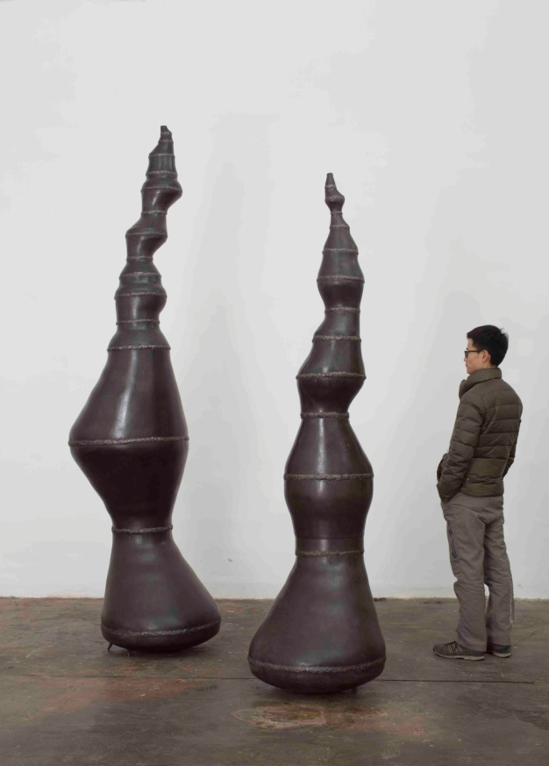

《蠢货（大）No.1》2016

《蠢货（大）No.2》2016

钢，空气

cm（尺寸待定）

cm（尺寸待定）

The Idiot（big）No.1,2016

steel, air

cm（尺寸待定）

cm（尺寸待定）

2

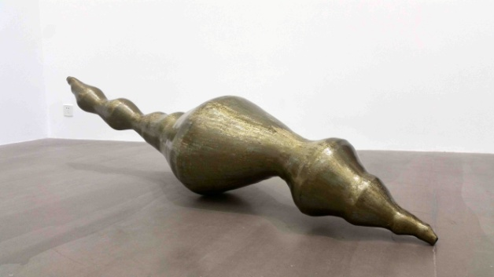

《饭桶》2016

钢，空气  
**13×30×19cm** **(尺寸待定）**

The Idiots,2016

steel, air

**13×30×19cm(尺寸待定）**

3

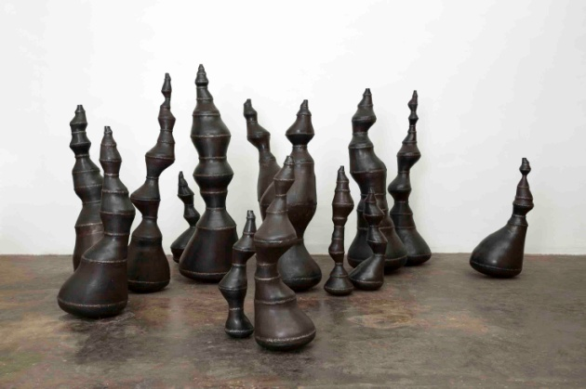

《蠢货》2016

钢，空气  
14件，尺寸从**13×30×19cm到54×79×69**cm不等（尺寸待定）

The Idiots,2016

steel, air

14pcs，sizes vary from **13×30×19cm to 54×79×69**cm（尺寸待定）

4

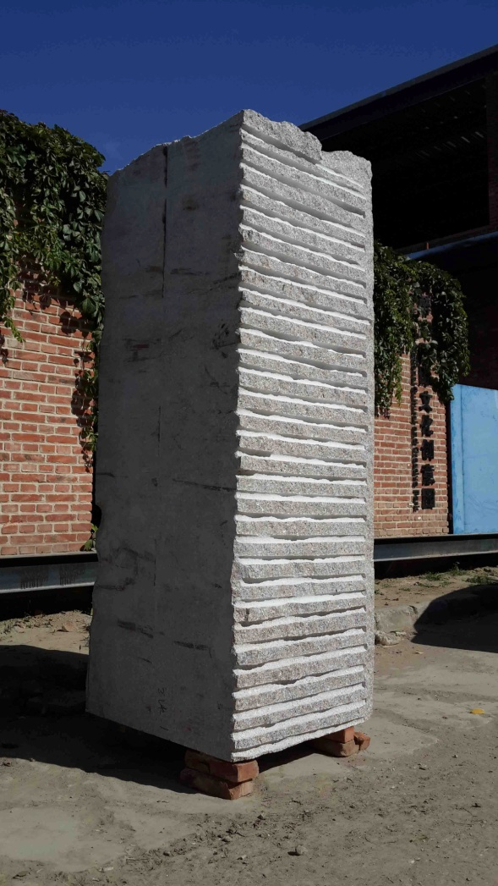

《未来开发计划：一件前卫雕塑》2015

大理石

210×90×80 cm（尺寸待定）

An Avant-garde Sculpture，2015

marble

210×90×80 cm（尺寸待定）

5

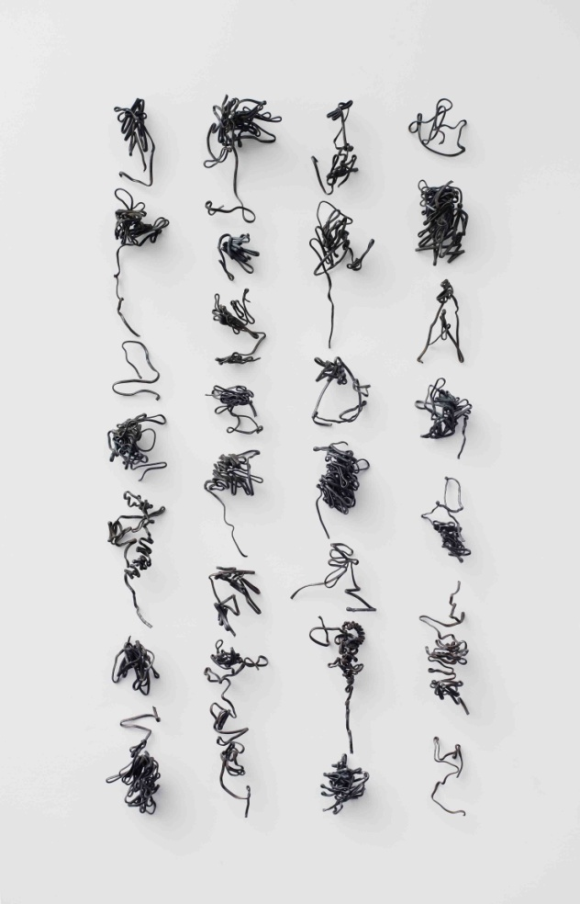

《七言绝句3》2015

钢筋

28件，尺寸从22×17×5cm到50×23×20cm不等，总尺寸250×125×20cm

Seven-character Quatrain 3,2015

rebar

28pcs，sizes vary from22×17×5cm to50×23×20cm，installation size 250×125×20cm

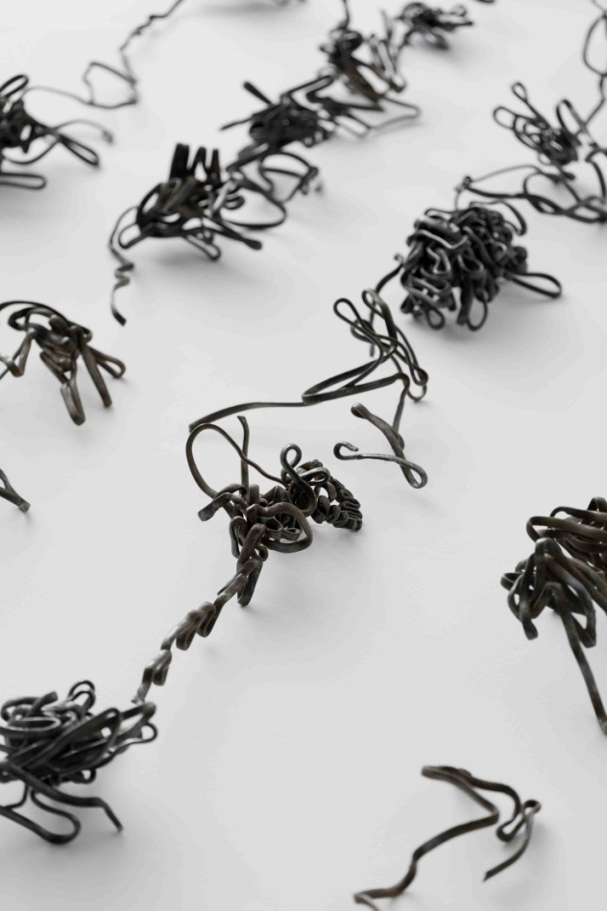

《七言绝句3》2015，局部

Seven-character Quatrain3,2015（detail）

6

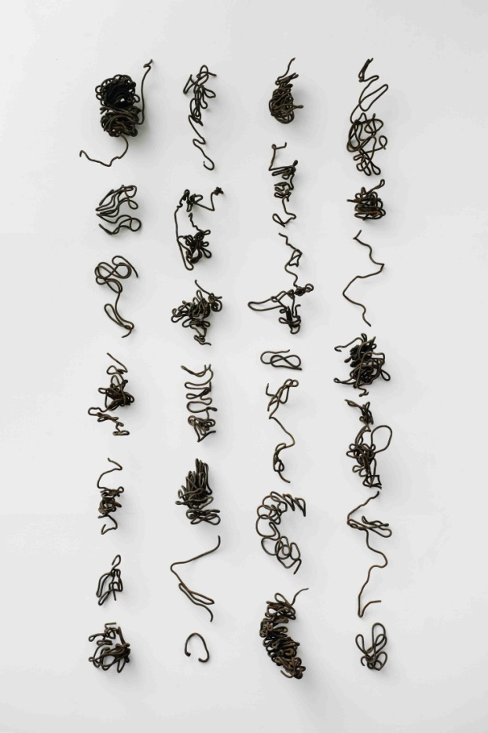

《七言绝句2》2015

钢筋

28件，尺寸从13×10×3cm到59×21×25cm不等，总尺寸260×130×25cm

Seven-character Quatrain 2,2015

rebar

28pcs，sizes vary from13×10×3cm to59×21×25cm，installation size 260×130×25cm

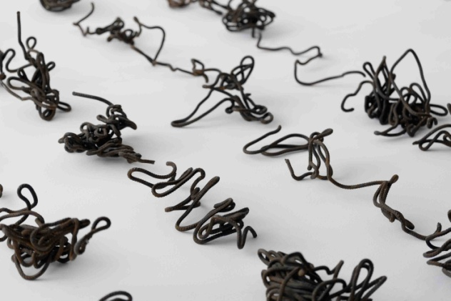

《七言绝句2》2015，局部

Seven-character Quatrain2,2015（detail）

7

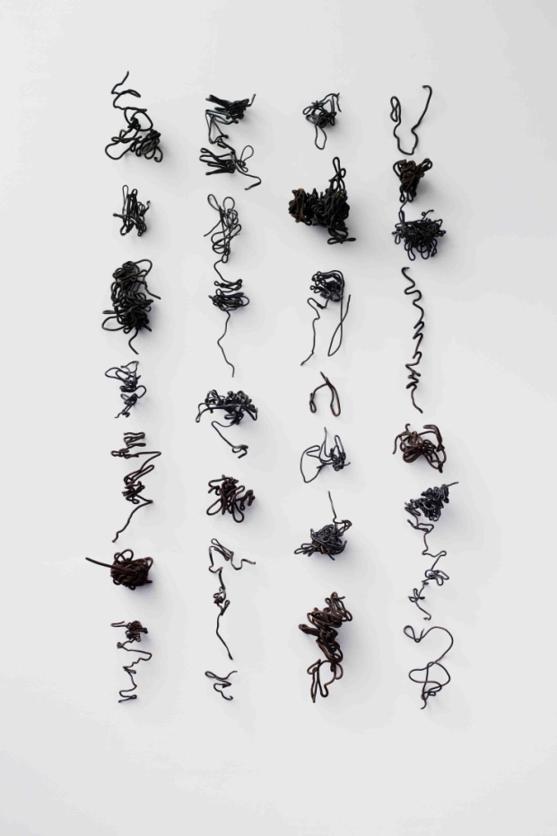

《七言绝句1》2015

钢筋

28件，尺寸从7×11.5×12cm到17×62×19cm不等，总尺寸248×136×32cm

Seven-character Quatrain 1,2015

rebar

28pcs，sizes vary from7×11.5×12cm to17×62×19cm，installation size 248×136×32cm

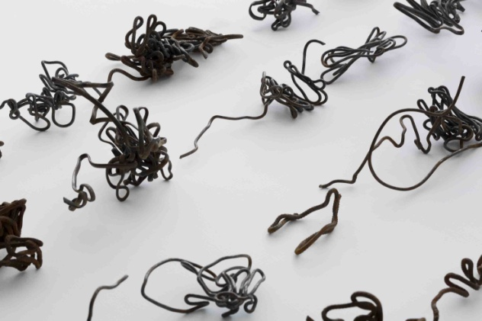

《七言绝句1》2015，局部

Seven-character Quatrain 1,2015（detail）

8

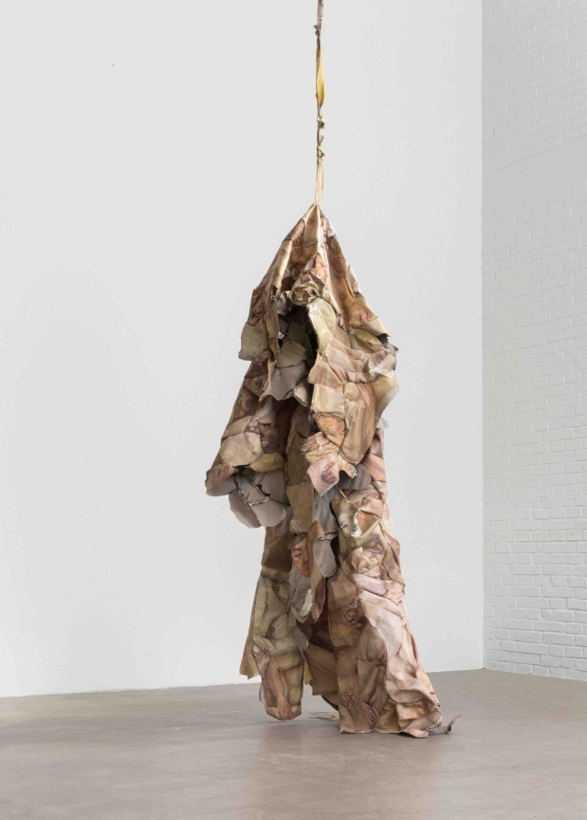

《坠落的肉身》2015

布面油画

223×120×90cm

The Falling Flesh,2015

oil on canvas

223×120×90cm

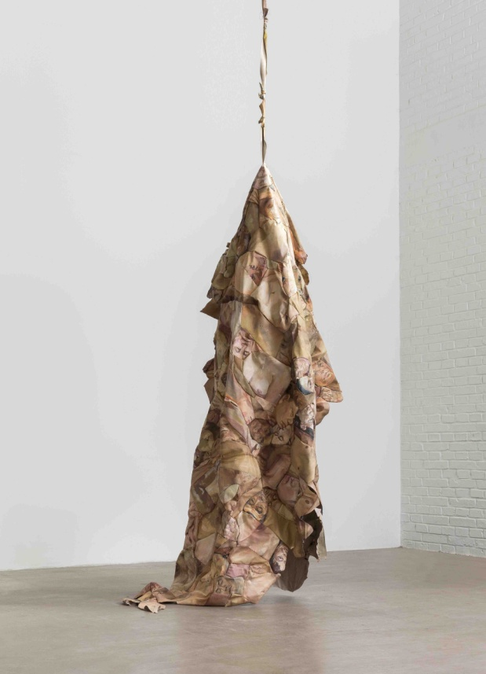

《坠落的肉身》2015

布面油画

223×120×90cm

The Falling Flesh,2015

oil on canvas

223×120×90cm

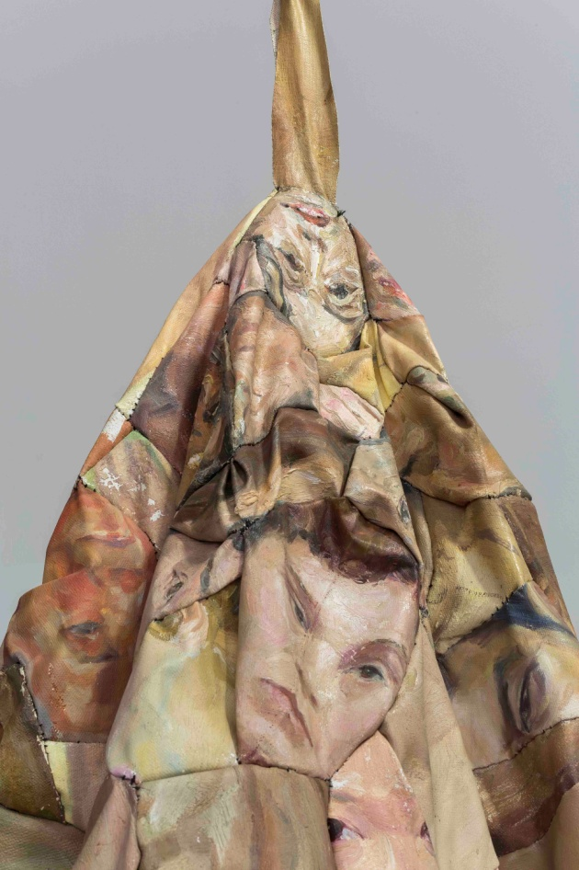

《坠落的肉身》2015，局部

The Falling Flesh,2015（detail）

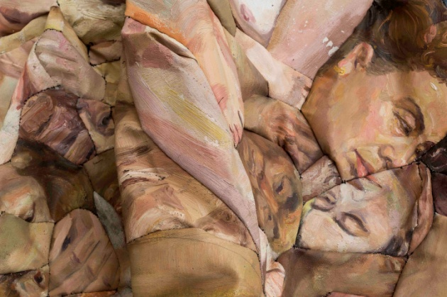

《坠落的肉身》2015，局部

The Falling Flesh,2015（detail）

9

#### 《秘密》 2015

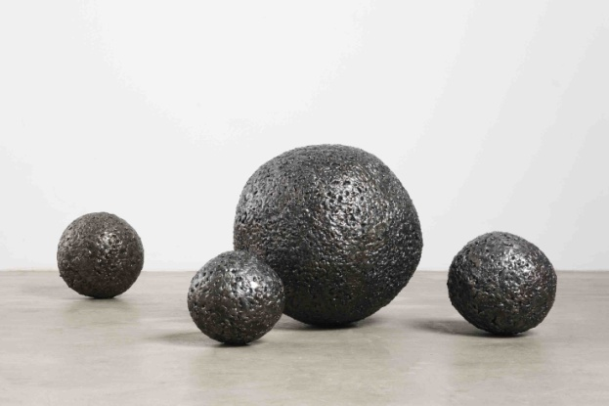

金属现成品，焊接材料  
4件，分别为直径18 cm，20 cm，22 cm和40cm

Secrets，2015

metal read-made objects， welded metal

4 pieces, ∅18 cm, ∅20 cm, ∅22 cm, ∅40 cm

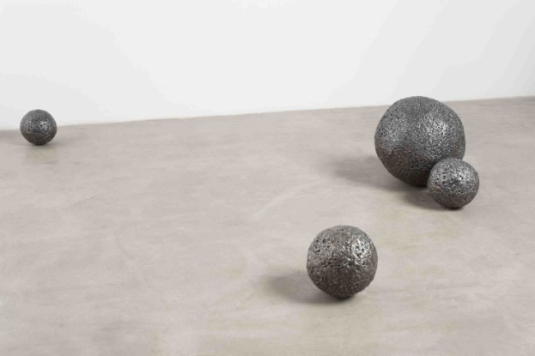

#### 《秘密》 2015

金属现成品，焊接材料  
4件，分别为直径18 cm，20 cm，22 cm和40cm

Secrets，2015

metal read-made objects， welded metal

4 pieces, ∅18 cm, ∅20 cm, ∅22 cm, ∅40 cm

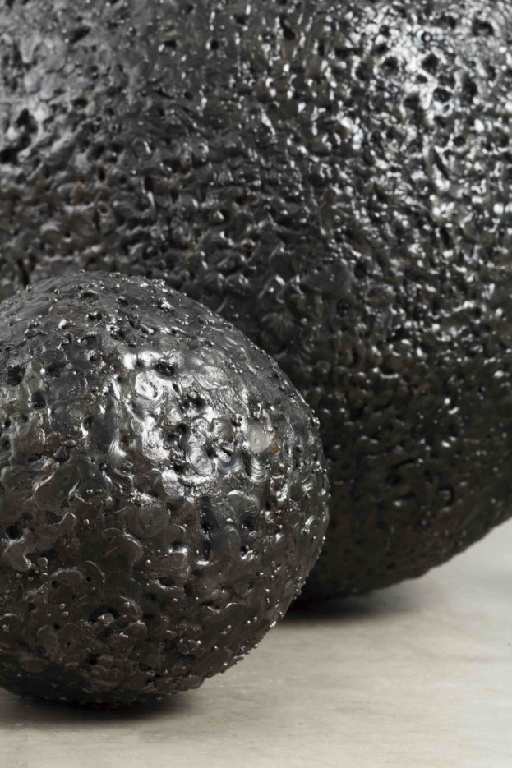

#### 《秘密》 2015，局部

Secrets，2015（detail）

#### 《秘密》 2015，局部

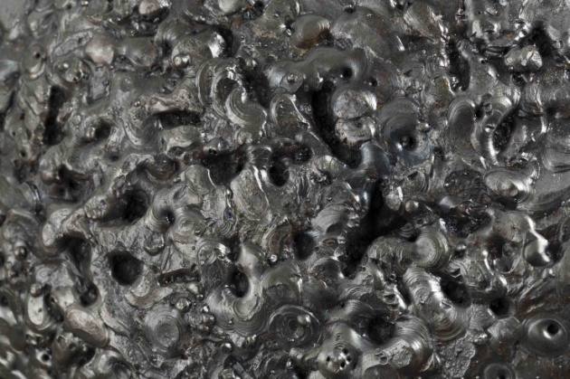

Secrets，2015（detail）

10

《一口气—父亲的塑像》2015

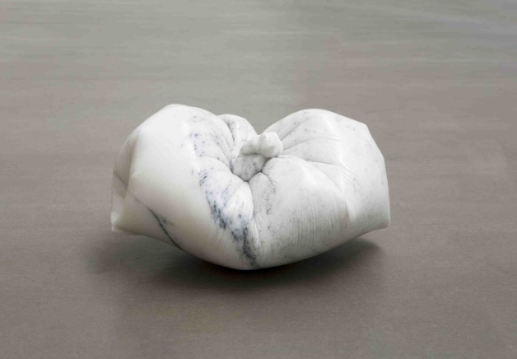

大理石

18×30×25cm

One Breath-Portrait of the Father，2015

marble

18×30×25cm

11

《仅仅是个偶然》2015

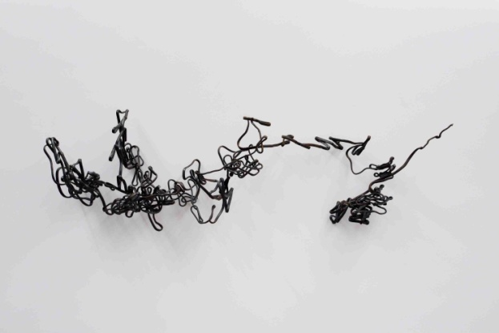

钢筋

50×145×30cm

Just an Accident，2015

rebar

50×145×30cm

12

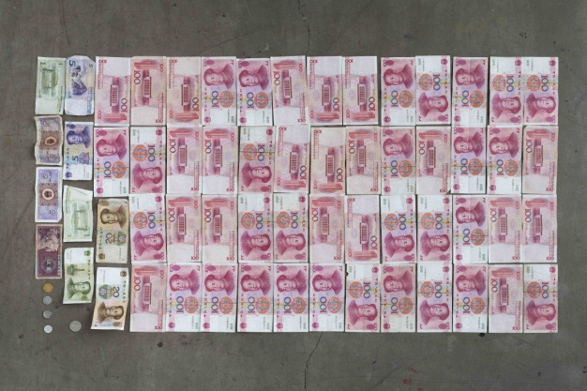

《5056.21》2015

c-print  
90×120 cm（尺寸待定）

作品《5056.21》（5+2AP）……以每版RMB 5056.21元的价格出售。

5056.21, 2015

c-print  
90×120 cm（尺寸待定）

13

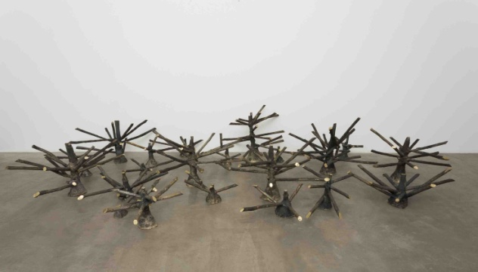

《无果之树No.2》2015

铸铜

22件，尺寸从13×30×19cm到54×79×69cm不等

这些树状的黄铜物件是艺术家从铸铜厂直接拿来的现成品，它们是从铸造完成的雕塑上面切下来的铜液流入雕塑的“管道”。 也可以把铸铜雕塑理解为这些“树”的果子。那整个过程就清楚了：一千多度的铜液通过“漏斗”注入分叉的通道进而到达所要铸造的雕塑。从根部流到主干进入枝杈到达末端进而结出果实，这正是完美的空间生长与延展的实例。它有树的形状，但不单是形似之树，更是空间延展的概念之树， 是关于空间的纯然之物。

Fruitless Trees No.2，2015

cast bronze

22pcs，sizes vary from 13×30×19cm to 54×79×69cm

I received these tree-shaped bronze casts ready-made directly from a bronze foundry. They have been cut from the "channels" where the molten metal flows into the sculpture cast from above. If we can understand the bronze sculptures as the fruit of these “trees,” then the whole process becomes clear: a molten copper alloy, at more than 1,000 degrees, flows through a "funnel" and along the forked channels until it reaches the sculpture’s form. It flows from the root, to the trunk, and into the branches, finally reaching the tips, where it becomes the fruit. This is a perfect example of a space for growth and extension. It has the shape of a tree, but it’s not just a tree shape, rather it's more of an extended space for the idea of a tree. It's about the space of mere objects.

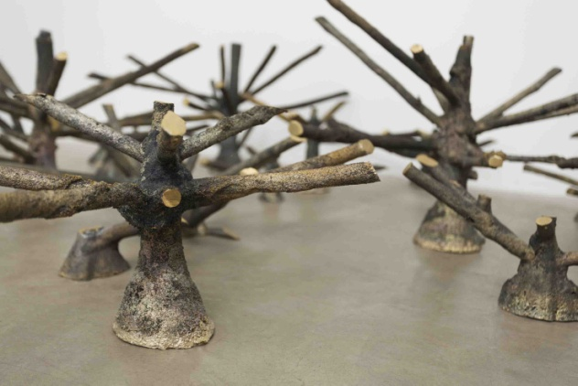

《无果之树No.2》2015,局部

Fruitless Trees No.2，2015（detail）

14

《The Family》2014

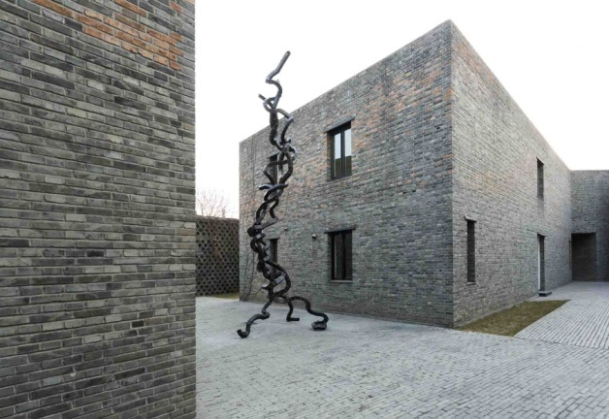

方形钢管，空气

602×220×168cm

The Family，2014

square steel tube, air  
602 × 220 × 168 cm

15

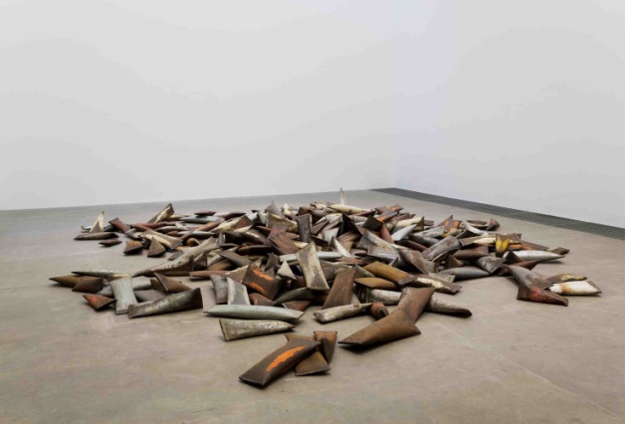

《人民》2014

旧钢管，空气

330件，尺寸从6× 35× 8 cm到10× 60× 35 cm不等

将收集而来的废旧钢管，在一段段截断之后将两头压扁，再经焊接而将其密闭成一个个憋着“一口气”的躯壳。它们虽形状、颜色各不相同但又无本质上的差别，犹如社会中的个人或者方阵中的士兵，某种程度上个体仅仅作为一个抽象的符号而存在着。艺术家让观众俯视并踩踏这些令人窒息的躯体：“我们在同情这种寄人篱下、任人践踏的境地的时候其实我们不也是处在相同的境遇中吗？我们在低头看它们的时候它们也在仰望着我们。”

The People, 2014

scrap steel tubes, air

330 pcs, sizes vary from 6× 35× 8 cm to 10× 60× 35 cm

The artist collected scrap steel tubes, cut them into sections, flattened them, and then welded the open ends together to make them airtight, so each piece becomes an empty shell enclosing a “breath of air” . Although their shapes and colors vary, they are not inherently different: just like an individual in society or a soldier in formation. To a certain extent, the individual only exists as an abstract idea. The artist have has the visitors look down upon and walk over the "stifled breaths": "We sympathize with this dependency: even though we are allowed to trample over them, are we not actually in the same situation? And so while looking at them, we are also looking at ourselves. "

《人民》2014

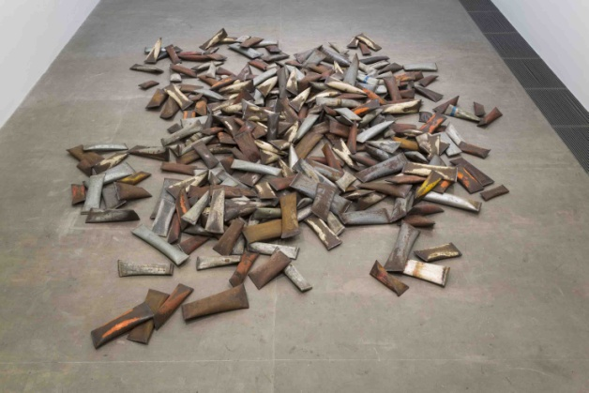

旧钢管，空气

330件，尺寸从6× 35× 8 cm到10× 60× 35 cm不等

The People, 2014

scrap steel tubes, air

330 pcs, sizes vary from 6× 35× 8 cm to 10× 60× 35 cm

《人民》2014，局部

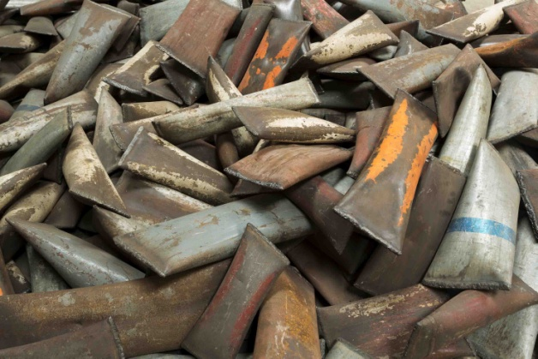

The People, 2014（detail）

16

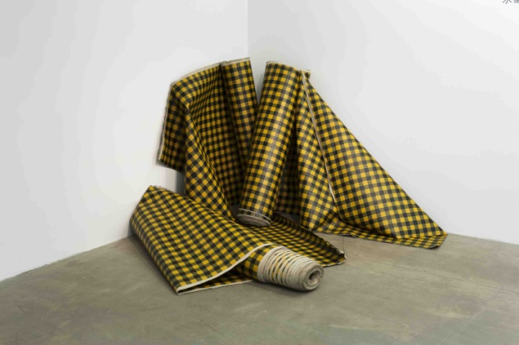

《黑黄格布》2014

布面丙烯

3卷，每卷115×3000cm

绘制在画布正反两面上的抽象图案既是两幅独立的抽象画，也相互印证使得这卷布成为对日常之物的戏仿。

Black and Yellow Cloth,2014

acrylic on canvas  
3 rolls, each roll 115 x 3000 cm

The abstract designs rendered on both sides of the canvas are pieces of abstract art and also their mutual corroboration turns this roll of fabric into a parody of an everyday object.

17

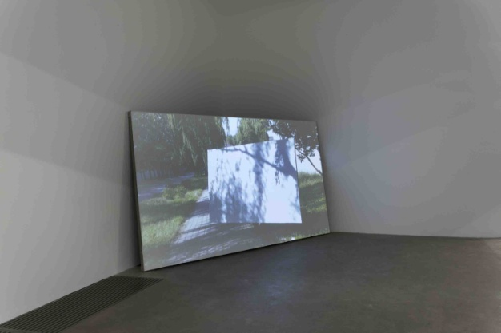

《从工作室到画廊的风景No.1》2014

布面影像

62′5″（影像时长），135×240cm（画布幅面）

艺术家搬着一幅空白画布从黑桥工作室步行至草场地的麦勒画廊，摇晃移动的画布与画面上匆匆来去的影子以及嘈杂的声音共同成为一个立体的“风景”。影像记录下的整个过程又一遍遍的在那块空白画布上重演。

From the Studio to The Gallery No.1,2014

video on canvas

video：62′5″,canvas：135×240cm

As a blank canvas is carried from the Heiqiao studio to Caochangdi’s Galerie Urs Meile (the site of the artwork’s first exhibition), the swaying of the canvas, the rush of shadows on its surface, and the hubbub of noise come together to make a multi-dimensional landscape. This whole process was recorded on video. In the exhibition space, the video’s “landscape” is played repeatedly on the surface of this blank canvas. We do not only see this landscape appearing, but we also see it fade away again and again.

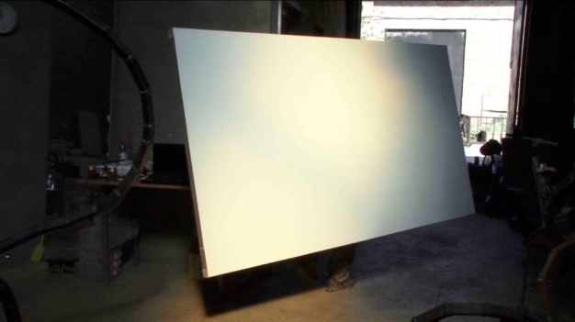

《从工作室到画廊的风景No.1》2014,录像截帧

From the Studio to The Gallery No.1,2014，film stills

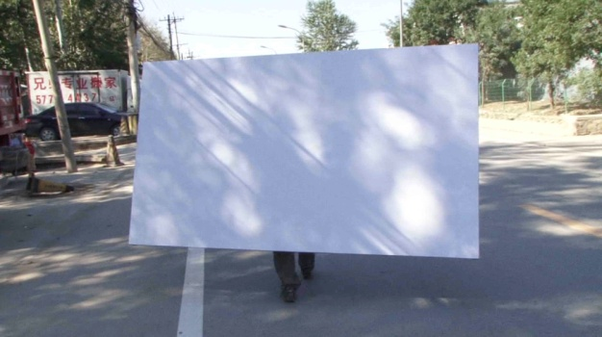

《从工作室到画廊的风景No.1》2014,录像截帧

From the Studio to The Gallery No.1,2014，film stills

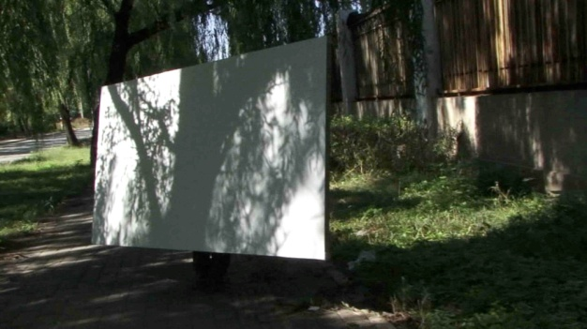

《从工作室到画廊的风景No.1》2014,录像截帧

From the Studio to The Gallery No.1,2014，film stills

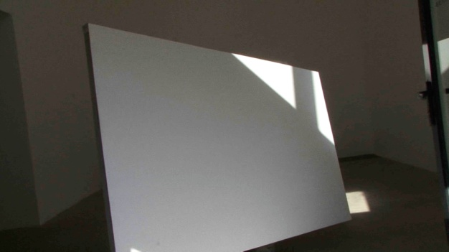

《从工作室到画廊的风景No.1》2014,录像截帧

From the Studio to The Gallery No.1,2014，film stills

18

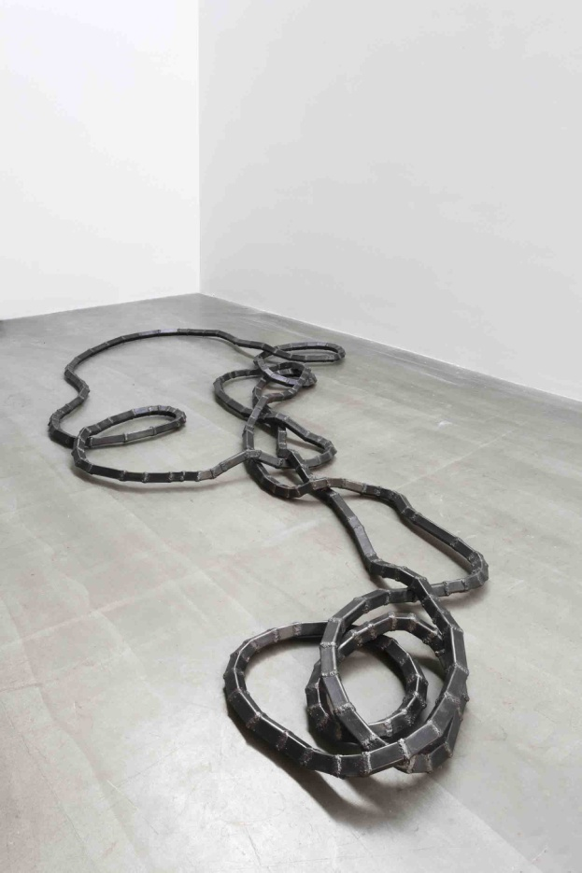

《空房间No.5》2014

方形钢管，空气  
15×433×206 cm

《空房间》系列探讨的是雕塑内部的空间。将方形钢管任意切割后随意组合焊接成曲曲折折的管道，管道首尾相接成为一个密闭循环的通道。在这里最重要的是循环反复的内部空间而非外形，故艺术家舍弃了对作品外形的设定和控制，甚至将整个制作全权交给助手，由其自行决定作品的尺寸甚至每个具体的形状。最后我们看到的就是这些偶然得来的随意之物。

#### The Empty Room No.5, 2014

square steel tube, air  
15 × 433 × 206 cm

*The Empty Room* deals with the empty space inside a space-filling sculpture. Square-shaped steel tubes were randomly cut and then welded together to form a coiled pipeline. The two ends were connected, becoming a closed circuit. To draw attention to the interior, rather than to the exterior, the artist had an assistant randomly create the form, so that he exercised no influence over the general shape of the work. Finally, what we see these accidental and random objects.

19

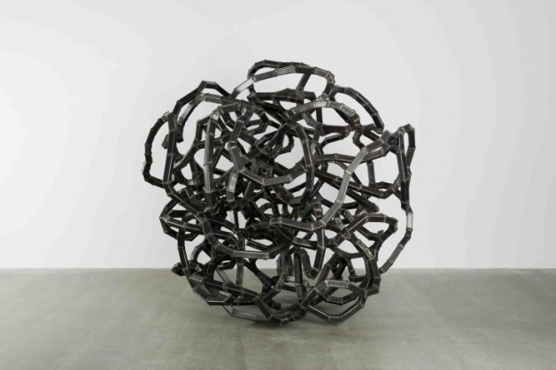

《空房间No.4》2014

方形钢管，空气  
182×205×195 cm

《空房间》系列探讨的是雕塑内部的空间。将方形钢管任意切割后随意组合焊接成曲曲折折的管道，管道首尾相接成为一个密闭循环的通道。在这里最重要的是循环反复的内部空间而非外形，故艺术家舍弃了对作品外形的设定和控制，甚至将整个制作全权交给助手，由其自行决定作品的尺寸甚至每个具体的形状。最后我们看到的就是这些偶然得来的随意之物。

#### The Empty Room No.4, 2014

square steel tube, air  
182 × 205 × 195 cm

*The Empty Room* deals with the empty space inside a space-filling sculpture. Square-shaped steel tubes were randomly cut and then welded together to form a coiled pipeline. The two ends were connected, becoming a closed circuit. To draw attention to the interior, rather than to the exterior, the artist had an assistant randomly create the form, so that he exercised no influence over the general shape of the work. Finally, what we see these accidental and random objects.

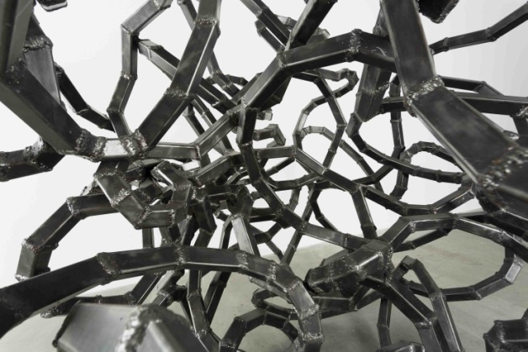

《空房间No.4》2014，局部

#### The Empty Room No.4,，2014，(detail)

20

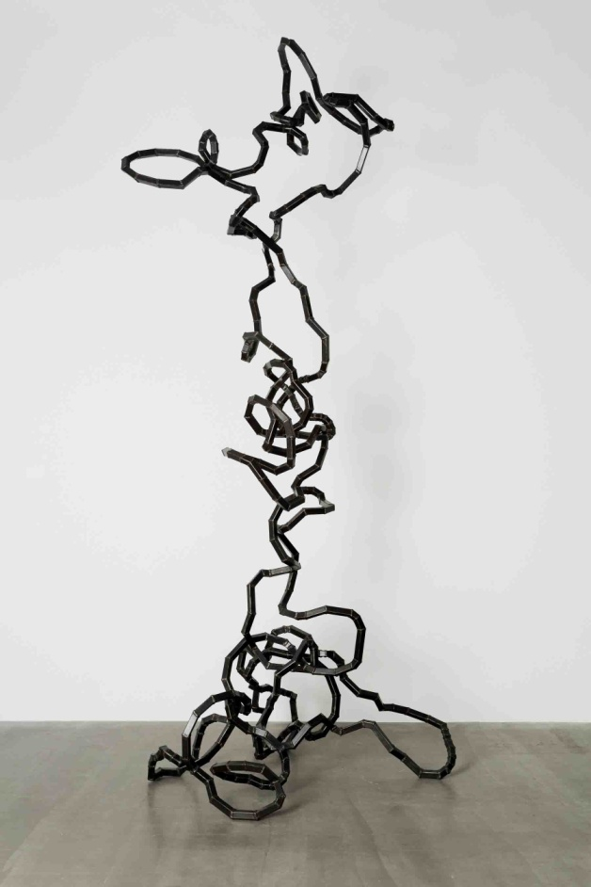

《空房间No.3》2014

方形钢管，空气  
492×200×178 cm

《空房间》系列探讨的是雕塑内部的空间。将方形钢管任意切割后随意组合焊接成曲曲折折的管道，管道首尾相接成为一个密闭循环的通道。在这里最重要的是循环反复的内部空间而非外形，故艺术家舍弃了对作品外形的设定和控制，甚至将整个制作全权交给助手，由其自行决定作品的尺寸甚至每个具体的形状。最后我们看到的就是这些偶然得来的随意之物。

#### The Empty Room No.3, 2014

square steel tube, air  
492 × 200 × 178 cm

*The Empty Room* deals with the empty space inside a space-filling sculpture. Square-shaped steel tubes were randomly cut and then welded together to form a coiled pipeline. The two ends were connected, becoming a closed circuit. To draw attention to the interior, rather than to the exterior, the artist had an assistant randomly create the form, so that he exercised no influence over the general shape of the work. Finally, what we see these accidental and random objects.

21

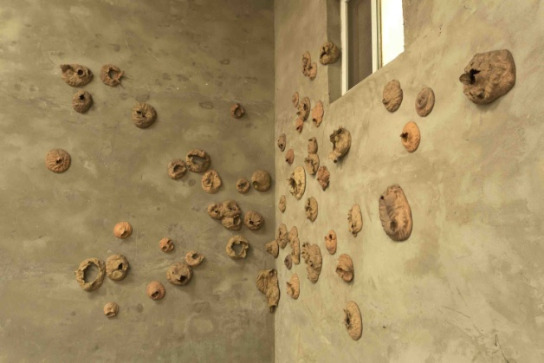

《嘭》2014

陶

53件，直径10cm-35cm

雕塑关乎空间，塑造空间，而在这里直接让空间（具体说是空气）参与到雕塑的塑造与成形。将一块雕塑泥捏成大概的碗状，碗口朝前摔去，“嘭”的一声，空气将泥巴炸破，而留下来的是经空气塑造过的泥巴，是泥巴对空气直接反应的结果。

BANG,2014

pottery clay

53pcs, ∅10cm-35cm

Sculptures are concerned with space. We usually present or convey space when we render an object (make a sculpture), whereas in *Bang*, I am directly allowing space (specifically air) to take part in the formation and shaping of the sculpture. I pinched clay into more or less a bowl shape and flung it with the opening of the bowl facing the wall. With a bang, the air exploded the clay into fragments, and what was left was the clay reshaped by the air. It’s the result of the clay directly responding to the air.

《嘭》2014，局部

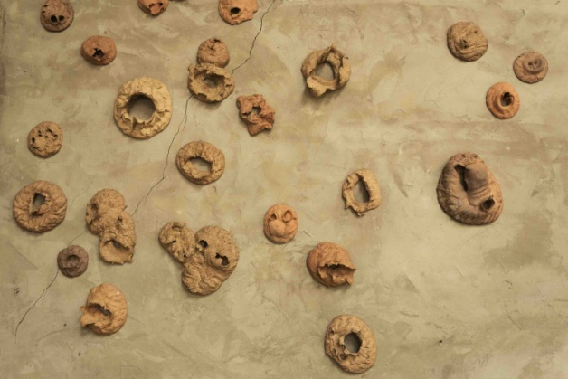

BANG,2014(detail)

22

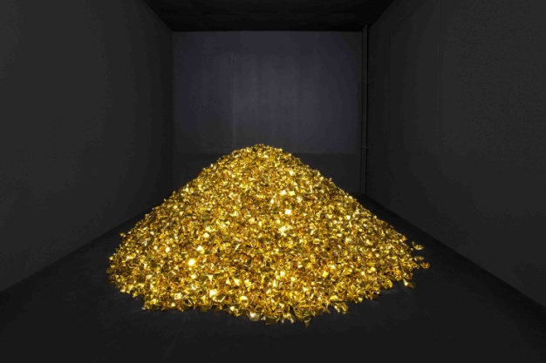

《金山No. 2》 2014

金纸

(高)100 ×直径 230 cm

《金山》会让人立刻联想起菲利克斯·冈萨雷斯-托雷斯（Felix Gonzalez-Torres）的糖果堆。但是和冈萨雷斯的糖果不同的是，这些小型纸雕塑并非观众的礼物，恰恰相反，它们通常被用作祭品。胡庆雁用金纸叠成的一个个烧给过世的人的“元宝”，于世人们的风俗观念中这些纸元宝会化为灰烬而去往另外的世界变成真金白银。因此，这些并没有按照供奉习俗而烧掉的纸元宝就成为一个金光灿灿而虚无缥缈的幻像。

Mountain of Gold No. 2, 2014

gold paper

(H)100 × Ø 230 cm

It reminds one at first glance of Felix Gonzalez-Torres's piles of candy. But unlike Gonzalez-Torres's series, the small paper shapes are not gifts for the visitor, but just the opposite; they are commonly used as an offering. The artist folded when it is burned for the dead. This ritual is performed with the idea that the deceased can use the money in afterlife. Hence, the fake, symbolic money, which is not used in strict accordance with the ritual, is an illusion emblematic of wrong goals and the fictitiousness of currency.

《金山No. 2》 2014，局部

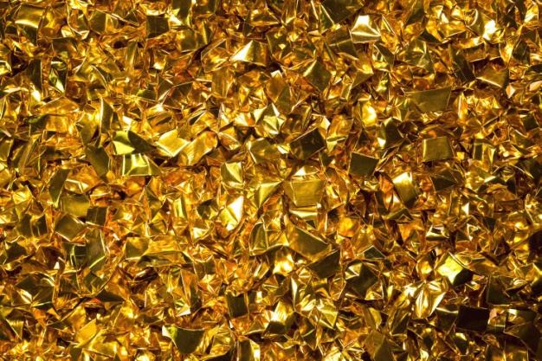

Mountain of Gold No. 2, 2014（detail）

23

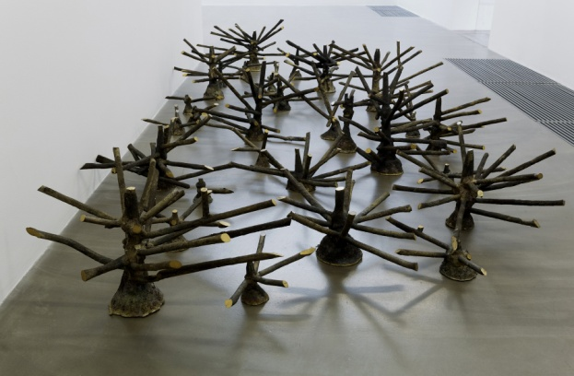

《无果之树》2014

铸铜

29件，尺寸从11×21×10cm到45.5×92×56cm不等

这些树状的黄铜物件是艺术家从铸铜厂直接拿来的现成品，它们是从铸造完成的雕塑上面切下来的铜液流入雕塑的“管道”。 也可以把铸铜雕塑理解为这些“树”的果子。那整个过程就清楚了：一千多度的铜液通过“漏斗”注入分叉的通道进而到达所要铸造的雕塑。从根部流到主干进入枝杈到达末端进而结出果实，这正是完美的空间生长与延展的实例。它有树的形状，但不单是形似之树，更是空间延展的概念之树， 是关于空间的纯然之物。

Fruitless Trees，2014

cast bronze

29pcs，sizes vary from 11×21×10cm to 45.5×92×56cm

I received these tree-shaped bronze casts ready-made directly from a bronze foundry. They have been cut from the "channels" where the molten metal flows into the sculpture cast from above. If we can understand the bronze sculptures as the fruit of these “trees,” then the whole process becomes clear: a molten copper alloy, at more than 1,000 degrees, flows through a "funnel" and along the forked channels until it reaches the sculpture’s form. It flows from the root, to the trunk, and into the branches, finally reaching the tips, where it becomes the fruit. This is a perfect example of a space for growth and extension. It has the shape of a tree, but it’s not just a tree shape, rather it's more of an extended space for the idea of a tree. It's about the space of mere objects.

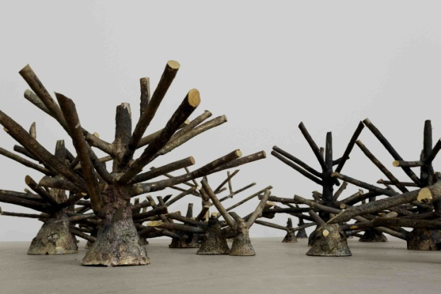

《无果之树》2014，局部

Fruitless Trees，2014（detail）

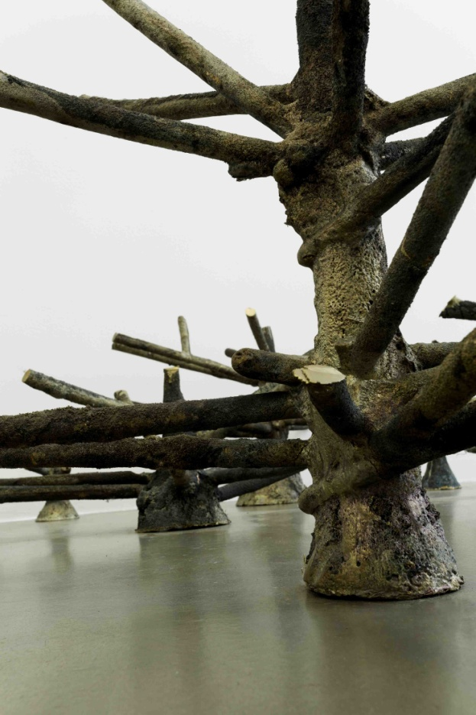

《无果之树》2014，局部

Fruitless Trees，2014（detail）

24

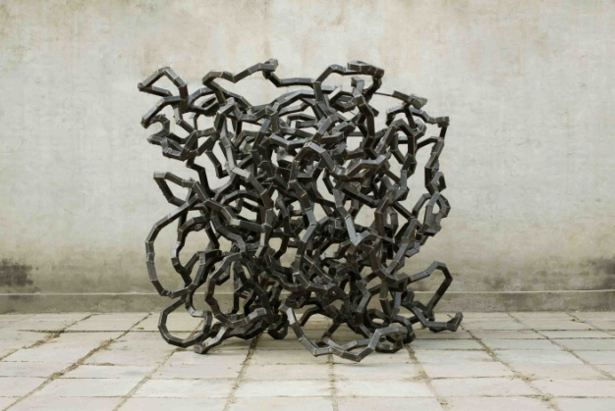

《空房间No.2》2013

方形钢管，空气  
190×212×185 cm

《空房间》系列探讨的是雕塑内部的空间。将方形钢管任意切割后随意组合焊接成曲曲折折的管道，管道首尾相接成为一个密闭循环的通道。在这里最重要的是循环反复的内部空间而非外形，故艺术家舍弃了对作品外形的设定和控制，甚至将整个制作全权交给助手，由其自行决定作品的尺寸甚至每个具体的形状。最后我们看到的就是这些偶然得来的随意之物。

#### The Empty Room No.2, 2013

square steel tube, air  
190 × 212 × 185 cm

*The Empty Room* deals with the empty space inside a space-filling sculpture. Square-shaped steel tubes were randomly cut and then welded together to form a coiled pipeline. The two ends were connected, becoming a closed circuit. To draw attention to the interior, rather than to the exterior, the artist had an assistant randomly create the form, so that he exercised no influence over the general shape of the work. Finally, what we see these accidental and random objects.

《空房间No.2》2013，局部

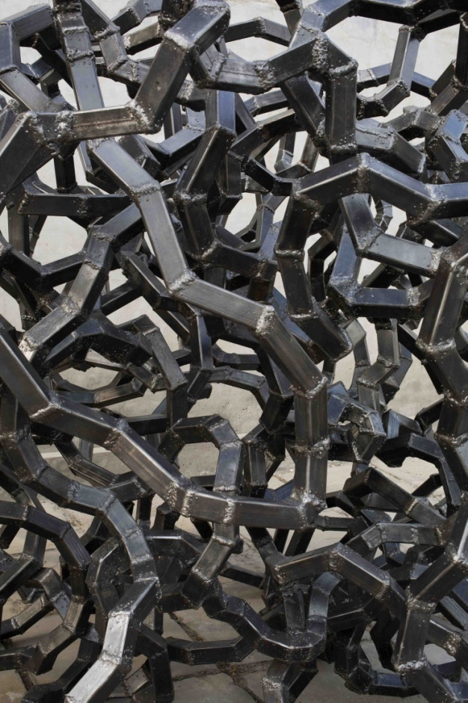

#### The Empty Room No.2, 2013（detail）

25

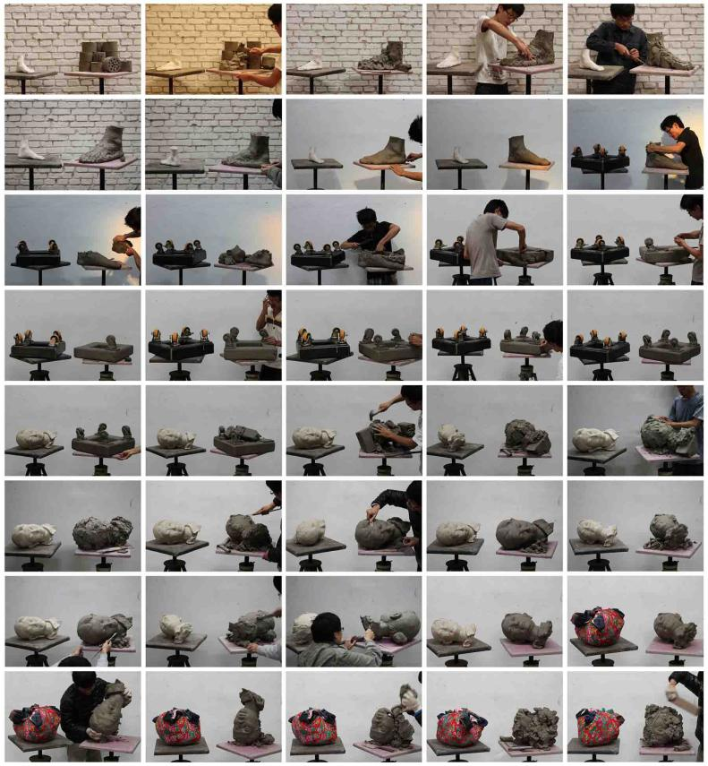

#### 《一堆泥巴的故事，81－120》2012-2013

c-print  
40张图片, 每张尺寸20×30 cm

“他是一个行者，用雕塑行走。从一个物体走向另一个物体。

像苦行僧，也像造物主————不收获什么，不到达雕塑，永远在路上。”

唐尧

Narrative by a Pile of Clay 81-120,2012-2013

c-print  
set of 40 photos, each 20×30 cm

"He is unwavering, never stopping; sculpture is his path, walking from one object to the next. Like an ascetic monk, yet also like a god-----not gaining anything, not reaching the sculpture, forever on the road."

Tang Yao

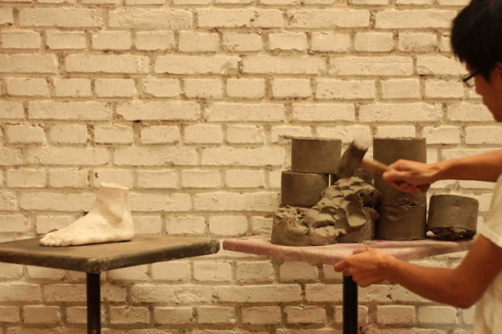

《一堆泥巴的故事，81-120》2012- 2013，局部82#

*Narrative by a Pile of Clay 81-120*, 2012- 2013(detail 82#)

《一堆泥巴的故事，81-120》2012- 2013，局部90#

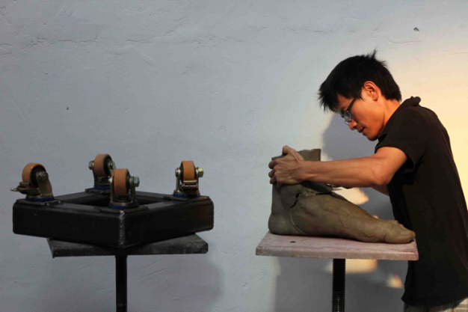

*Narrative by a Pile of Clay 81-120*, 2012- 2013(detail 90#)

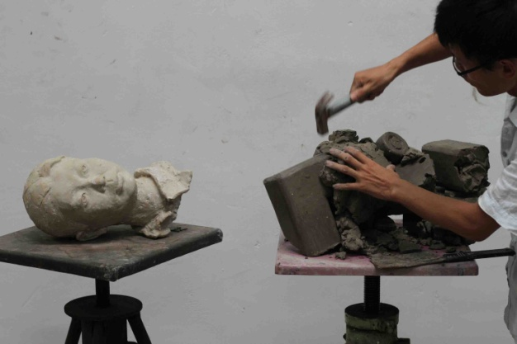

《一堆泥巴的故事，81-120》2012- 2013，局部103#

*Narrative by a Pile of Clay 81-120*, 2012- 2013(detail 103#)

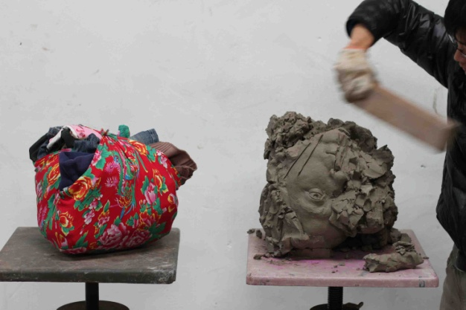

《一堆泥巴的故事，81-120》2012- 2013，局部120#

*Narrative by a Pile of Clay 81-120*, 2012- 2013(detail 120#)

26

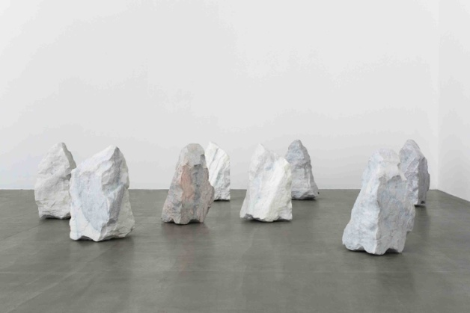

《8版》2013

大理石（以一块石头为模型制作的复制品， 由不同的大理石切割而成）  
8件，每件55×33×32 cm

8块长相一模一样的石头是以捡来的一块石头为模型的复制品，确切说是克隆，因为它们具有的不仅仅是那块石头的外形，材质、重量及化学成分也都基本一样。它们是原版的复制和山寨，但又是实实在在的自在之物。雕塑作品中，通常约定俗成的把8个版本的拷贝视为原作，这里8个版本的整体成为一件作品，它更多的是关于批量复制、山寨以及原作与赝品等社会现实。

#### Edition of 8, 2013

marble (replicas of a single rock, cut out of several marble blocks)  
8 pieces, each 55 x 33 x 32 cm

These eight pieces of stone that look exactly the same are modeled on a stone that was just picked up. We can call them clones, because not only do they have the same appearance as that stone, their texture, weight and chemical composition are all essentially the same. They are copies and knock-offs of the original, but they are also the real thing itself. Among sculptures, it is usually customary to view the edition of eight copies as an original. Here the entire work of the edition of eight is taken as a single artwork. It is more about the copied batch, knock-offs and the original with imitation and other realities of society.

《8版》2013，局部

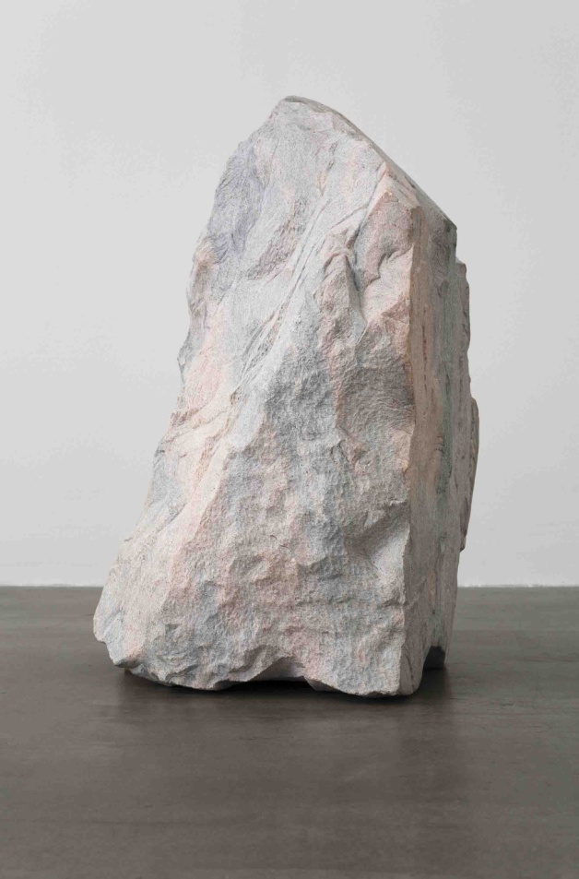

#### Edition of 8, 2013(detail)

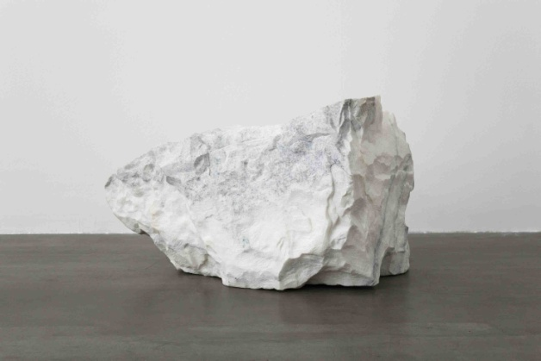

《8版》2013，局部

#### Edition of 8, 2013(detail)

27

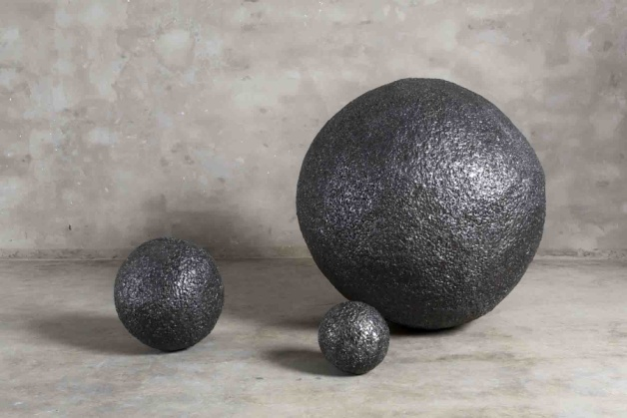

#### 《电动机，千斤顶和铁柜子》 2013

金属现成品（电动机，千斤顶，铁柜），焊接材料

3 pieces, ∅23 cm, ∅40 cm, ∅100 cm

铁球形成之前，是三个形状功能完全不同的物件。从电动机上的某一点开始电焊，随着电焊所融化的焊接材料的堆积，它开始一点点变胖。当焊点叠加到几万次的时候，它的原初形象已经完全消失了，成为一个不可辨认的铁质球状物。另外两个也是同样的“生长”而来。三个完全不相关的功能形象各异的物件最后除了大小之外，没有什么区别。这一过程抹掉了各自的个性，但突出了物质的共性。提示了功能形象的流动转化以及不相关之物的联系。

Electromotor, Lifting Jack, and Iron Cabinet, 2013

metal read-made objects (electromotor, lifting jack, and iron cabinet), welded metal  
3 pieces, ∅23 cm, ∅40 cm, ∅100 cm

Before they became iron spheres, they were three objects with completely different shapes and functions. Welding was started from a certain point on the motor and as the molten metal began to accumulate, the shape begins to get fatter. After welding tens of thousands of spots, the object's original form has completely gone and it has become unrecognizably an iron sphere. The other two objects are "grown" in the same way. These three objects that are completely unrelated in function and appearance are, in the end, no different except for their size. The process has erased their individuality, but highlighted their commonalities. It demonstrates the fluidity of function and form and the connection between unrelated objects.

#### 《电动机，千斤顶和铁柜子》 2013，局部

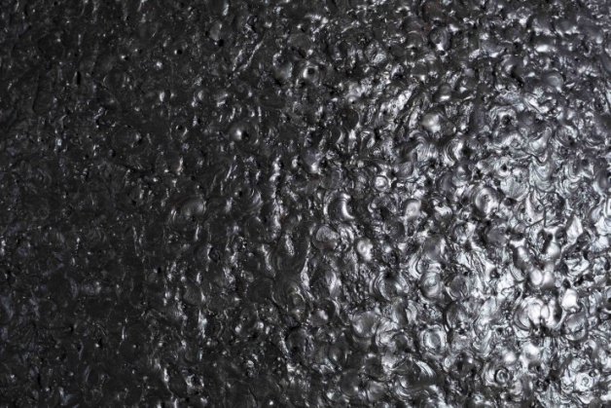

Electromotor, Lifting Jack, and Iron Cabinet, 2013(detail)

28

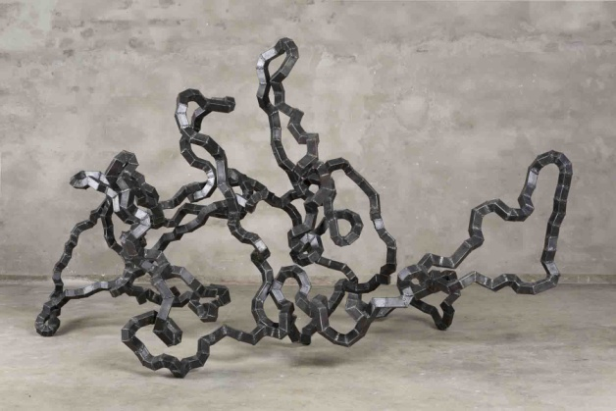

《空房间》2013

方形钢管，空气  
157×272×146 cm

《空房间》系列探讨的是雕塑内部的空间。将方形钢管任意切割后随意组合焊接成曲曲折折的管道，管道首尾相接成为一个密闭循环的通道。在这里最重要的是循环反复的内部空间而非外形，故艺术家舍弃了对作品外形的设定和控制，甚至将整个制作全权交给助手，由其自行决定作品的尺寸甚至每个具体的形状。最后我们看到的就是这些偶然得来的随意之物。

#### The Empty Room, 2013

square steel tube, air  
157 × 272 × 146 cm

*The Empty Room* deals with the empty space inside a space-filling sculpture. Square-shaped steel tubes were randomly cut and then welded together to form a coiled pipeline. The two ends were connected, becoming a closed circuit. To draw attention to the interior, rather than to the exterior, the artist had an assistant randomly create the form, so that he exercised no influence over the general shape of the work. Finally, what we see these accidental and random objects.

29

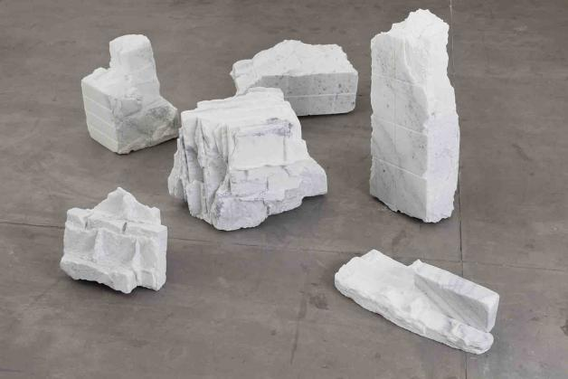

#### 《纪念品》 2013

大理石 （以拆迁现场捡到的建筑残块为模型制作的复制品，6件一组，每件由一整块大理石切割而成）  
6件，不同尺寸，从16×52×22 cm 到 60×60×40 cm

将拆迁现场捡来的建筑残块雕刻成大理石材质，但它并非意在对拆迁、破坏等社会问题加以述说，所以从雕塑的形象上寻找作品意义的流行做法在这里似乎不合适。“纪念品”不是那类对社会隐喻和观念进行表达的作品，而是关于雕塑作为现实的纪念品的处境和现状，所以它是关于雕塑自身的。

Souvenir, 2013

marble (replica of a rubble piece from a ruined hutong, cut out of a single marble block)  
6 pieces, different sizes from approx. 16×52×22 cm to 60×60×40 cm

Fragments picked up from a demolition site were carved so that they have the texture of marble. But it's not really intended that they tell the story of social issues such as relocation and destruction. So it seems fitting here to look for the direction of the artwork's meaning from the sculpture's form. *Souvenir* is not an artwork that expresses a social metaphor or concept, rather it is about the sculpture as a souvenir of the real situation and condition; so it is about the sculpture itself.

《纪念品》 2013，局部

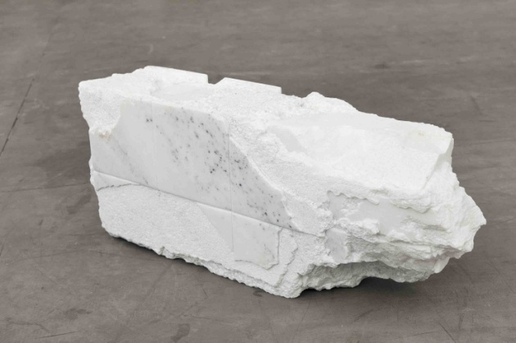

Souvenir, 2013(detail)

《纪念品》 2013，局部

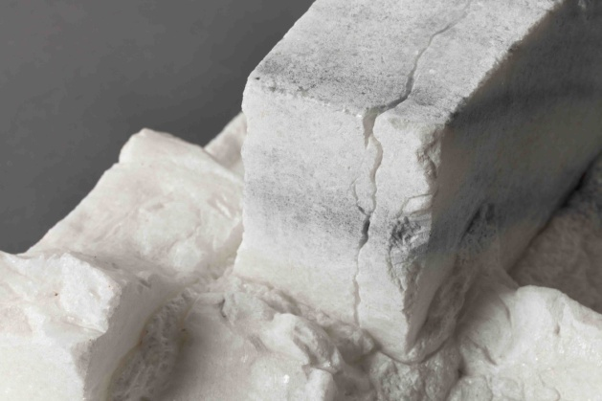

Souvenir, 2013(detail)

30

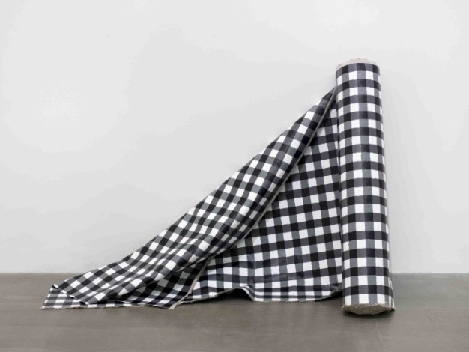

《一卷黑白格布》2012

布面丙烯  
115 x 3000 cm

绘制在画布正反两面上的抽象图案既是两幅独立的抽象画，也相互印证使得这卷布成为对日常之物的戏仿。

#### A Roll of Black and White Plaid Cloth, 2012

acrylic on canvas  
115 x 3000 cm

The abstract designs rendered on both sides of the canvas are pieces of abstract art and also their mutual corroboration turns this roll of fabric into a parody of an everyday object.

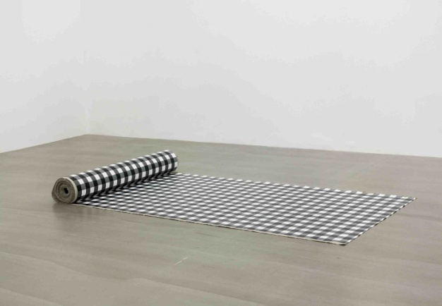

《一卷黑白格布》2012

布面丙烯  
115 x 3000 cm

#### A Roll of Black and White Plaid Cloth, 2012

acrylic on canvas  
115 x 3000 cm

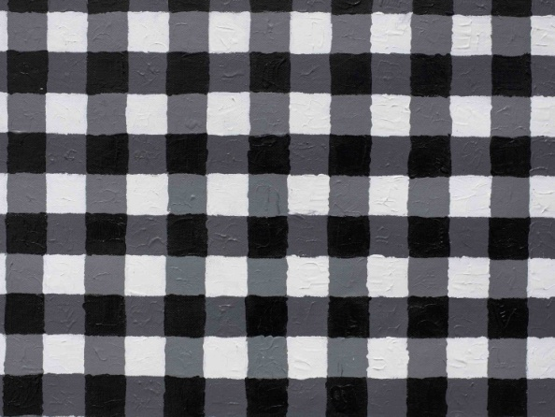

《一卷黑白格布》2012，局部

#### A Roll of Black and White Plaid Cloth, 2012(detail)

31

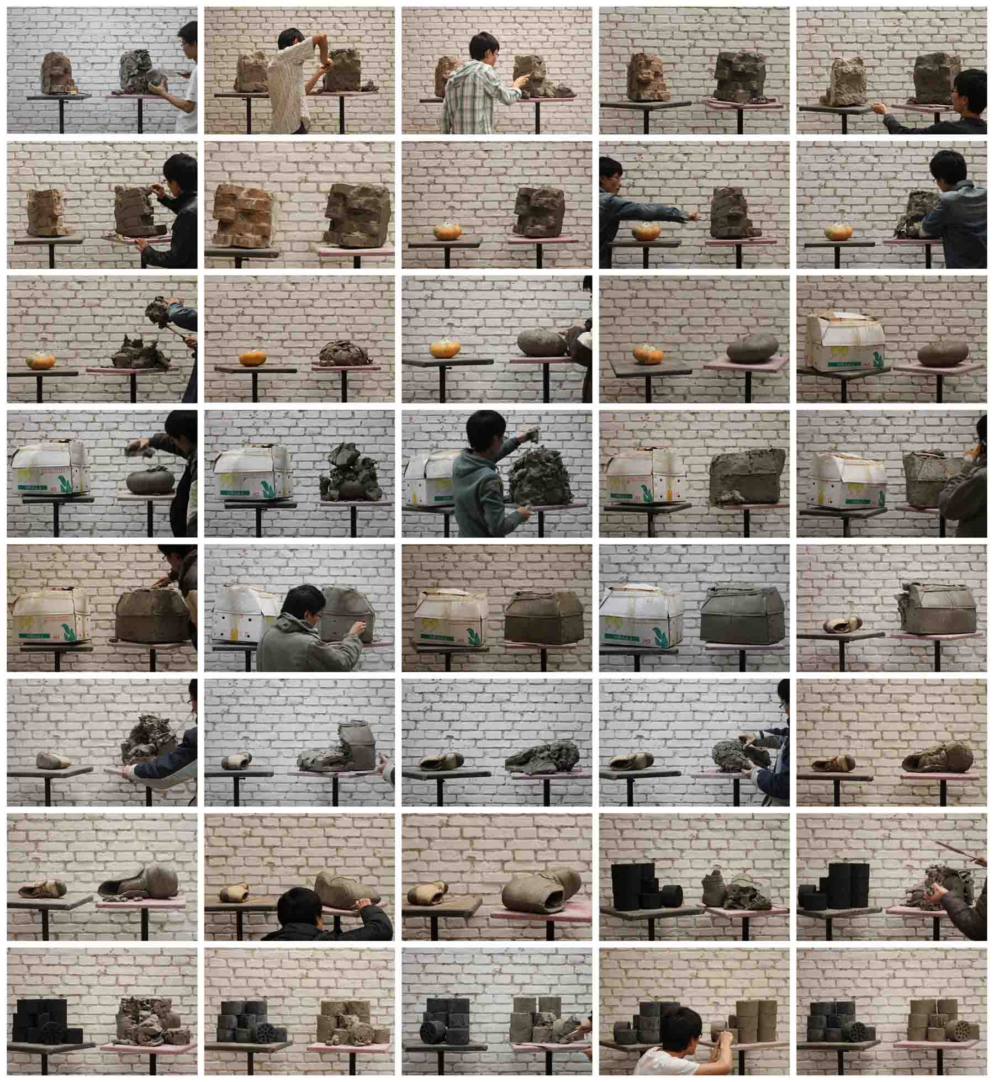

#### 《一堆泥巴的故事，41－80》2010-2012

c-print  
40张图片, 每张尺寸20×30 cm

“他是一个行者，用雕塑行走。从一个物体走向另一个物体。

像苦行僧，也像造物主————不收获什么，不到达雕塑，永远在路上。”

唐尧

Narrative by a Pile of Clay 41-80,2011-2012

c-print  
set of 40 photos, each 20×30 cm

"He is unwavering, never stopping; sculpture is his path, walking from one object to the next. Like an ascetic monk, yet also like a god-----not gaining anything, not reaching the sculpture, forever on the road."

Tang Yao

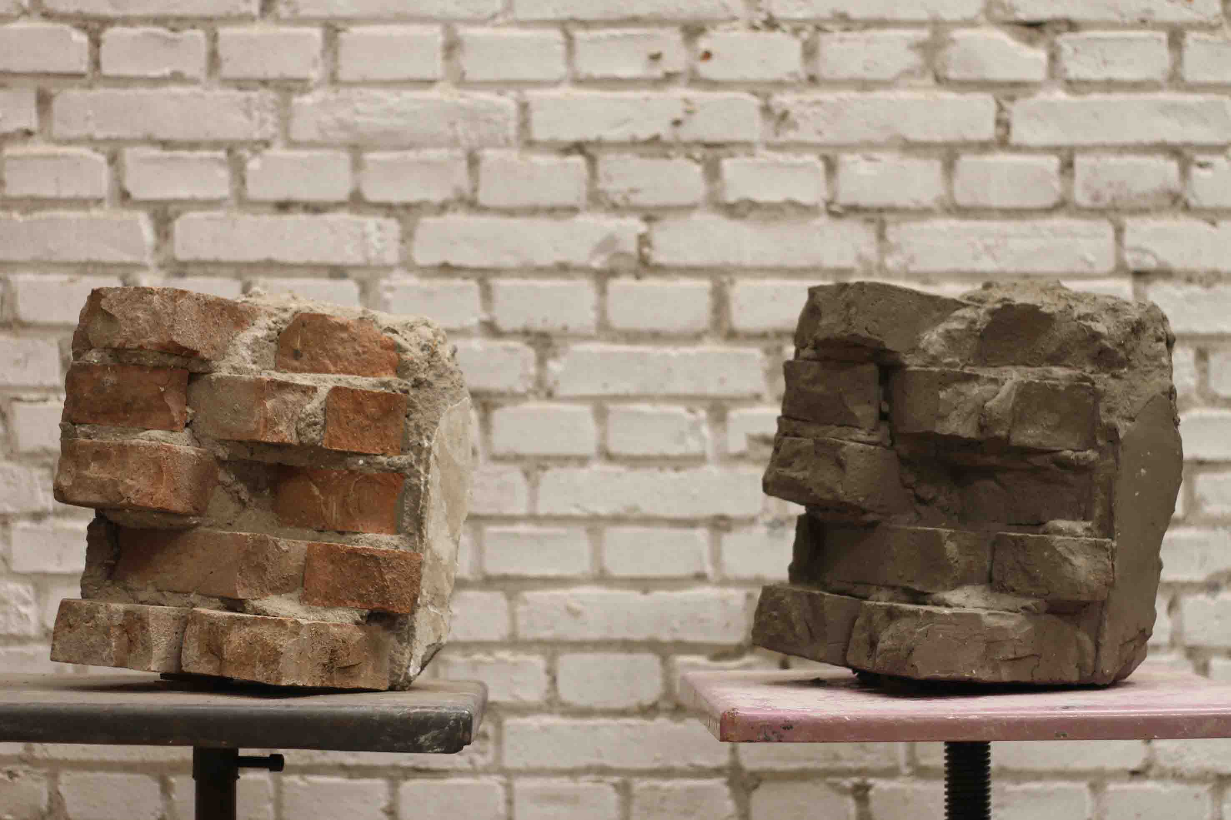

《一堆泥巴的故事，41－80》2010-2012，局部47#

Narrative by a Pile of Clay 41-80,2011-2012 (detail 47#)

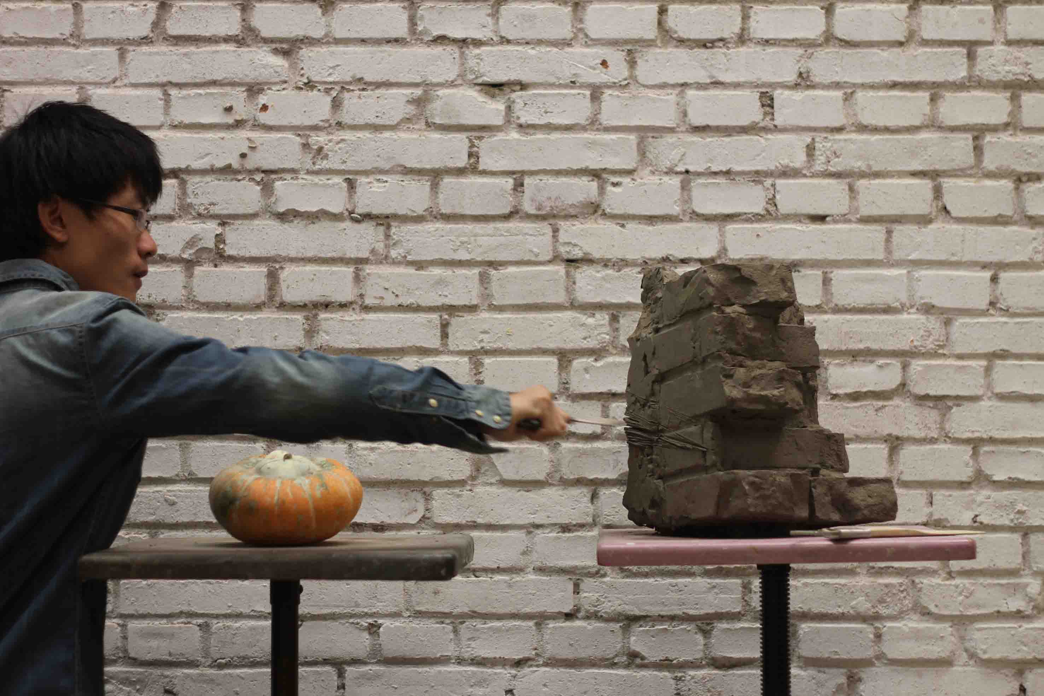

《一堆泥巴的故事，41－80》2010-2012，局部49#

*Narrative by a Pile of Clay* 41-80,2011-2012 (detail 49#)

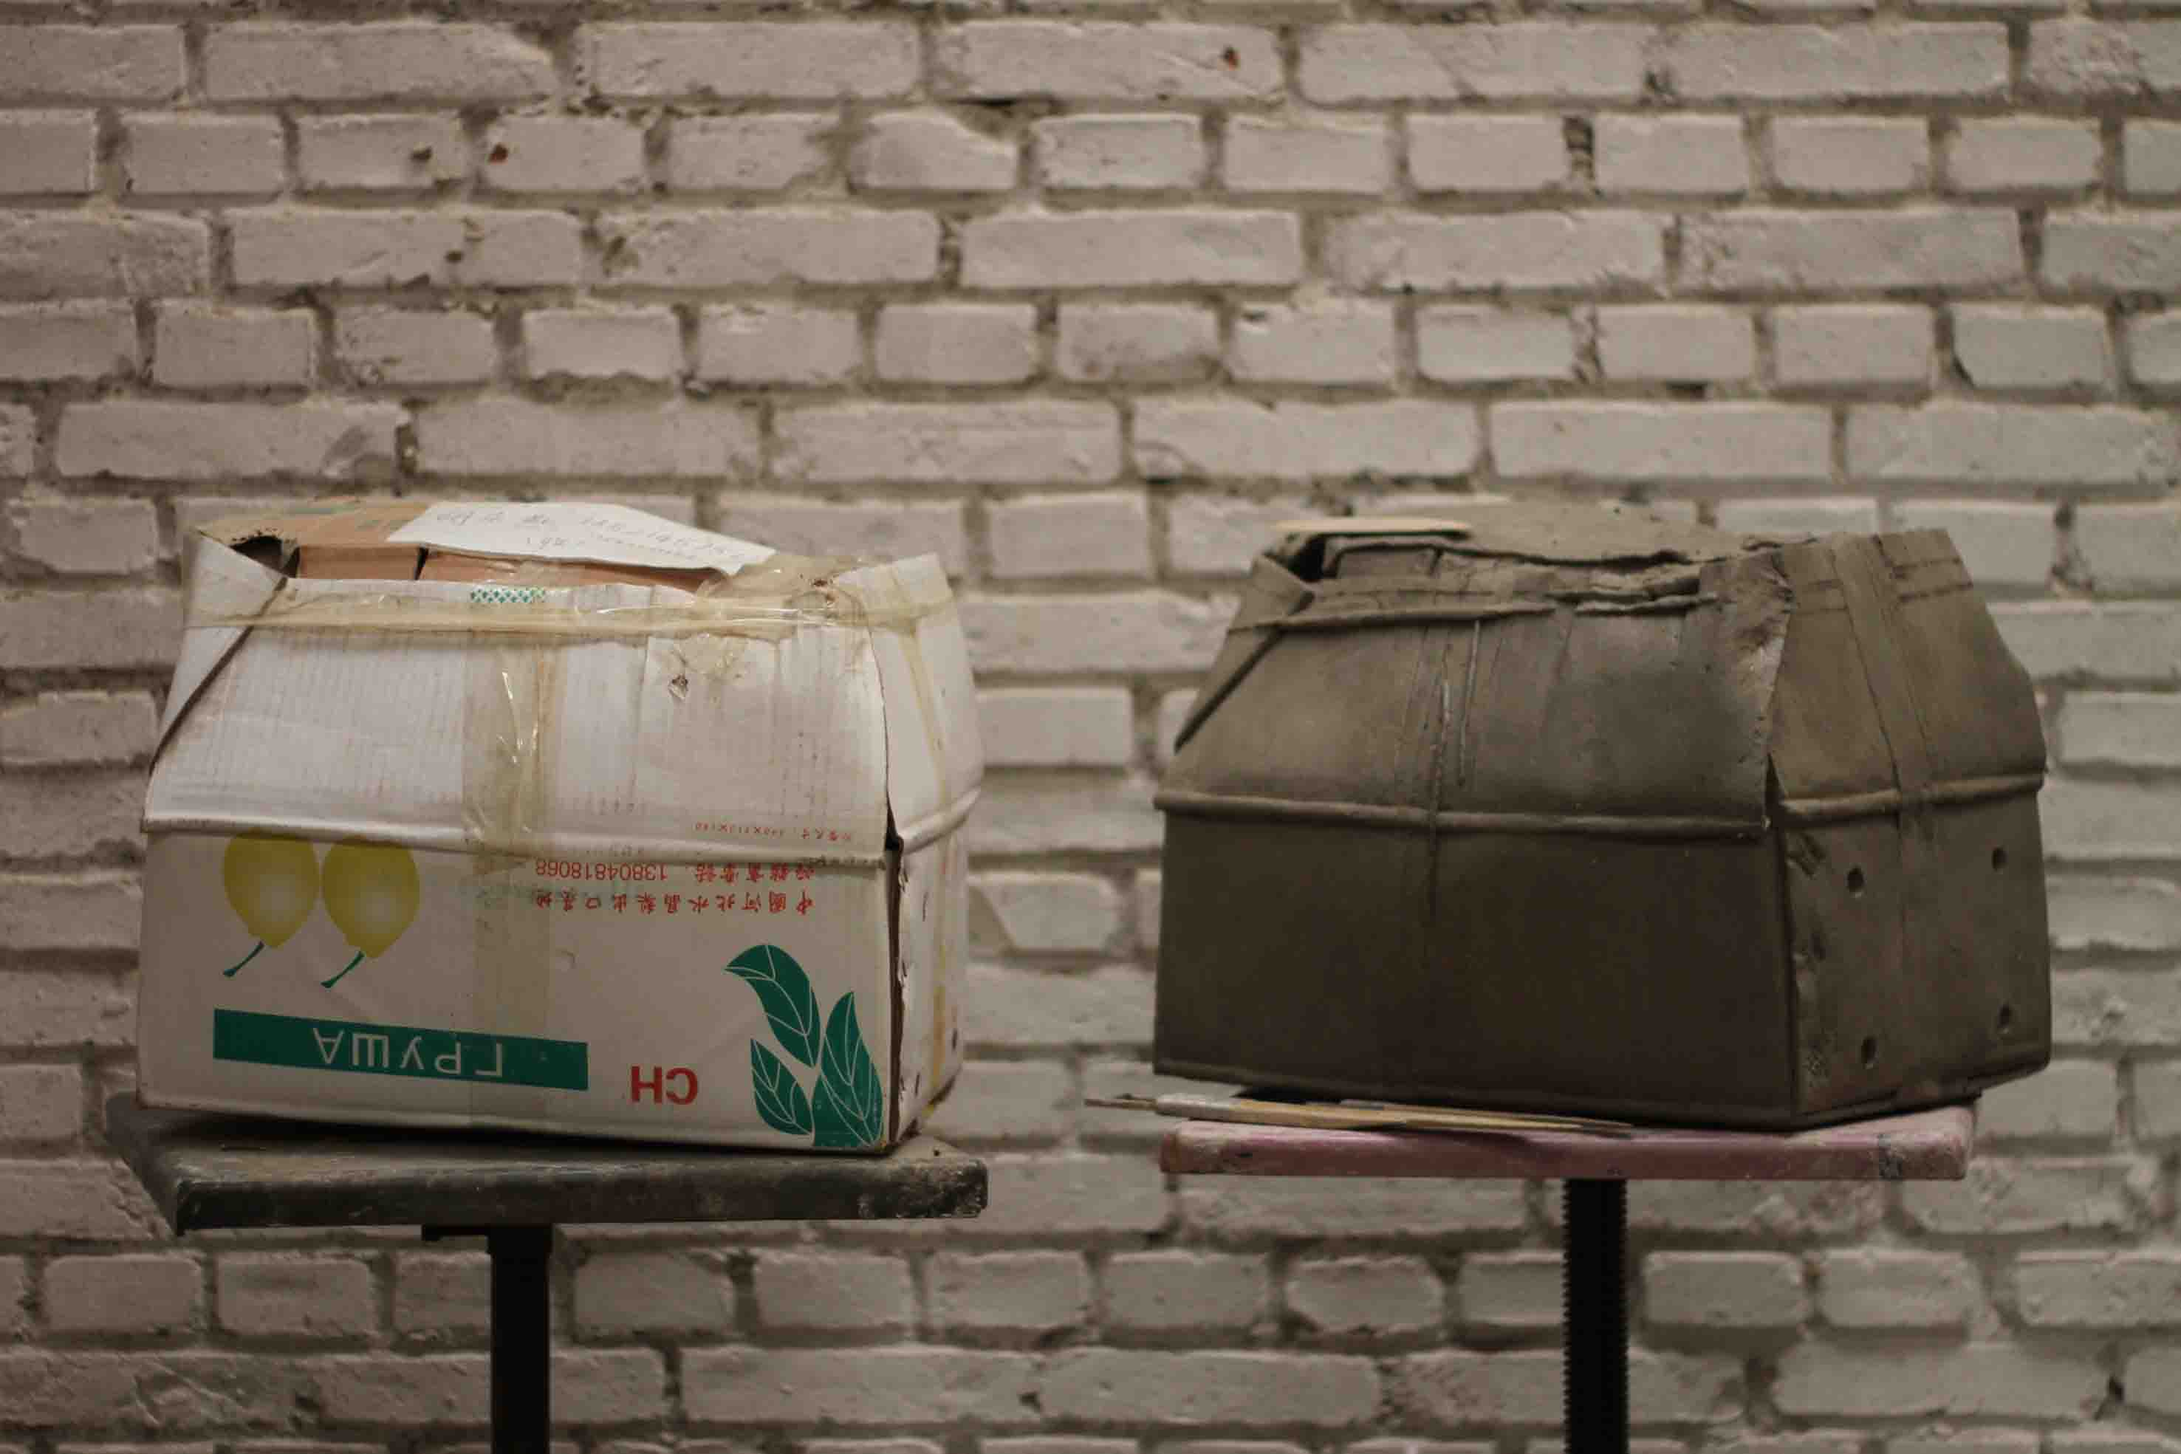

《一堆泥巴的故事，41－80》2010-2012，局部63#

*Narrative by a Pile of Clay* 41-80,2011-2012 (detail 63#)

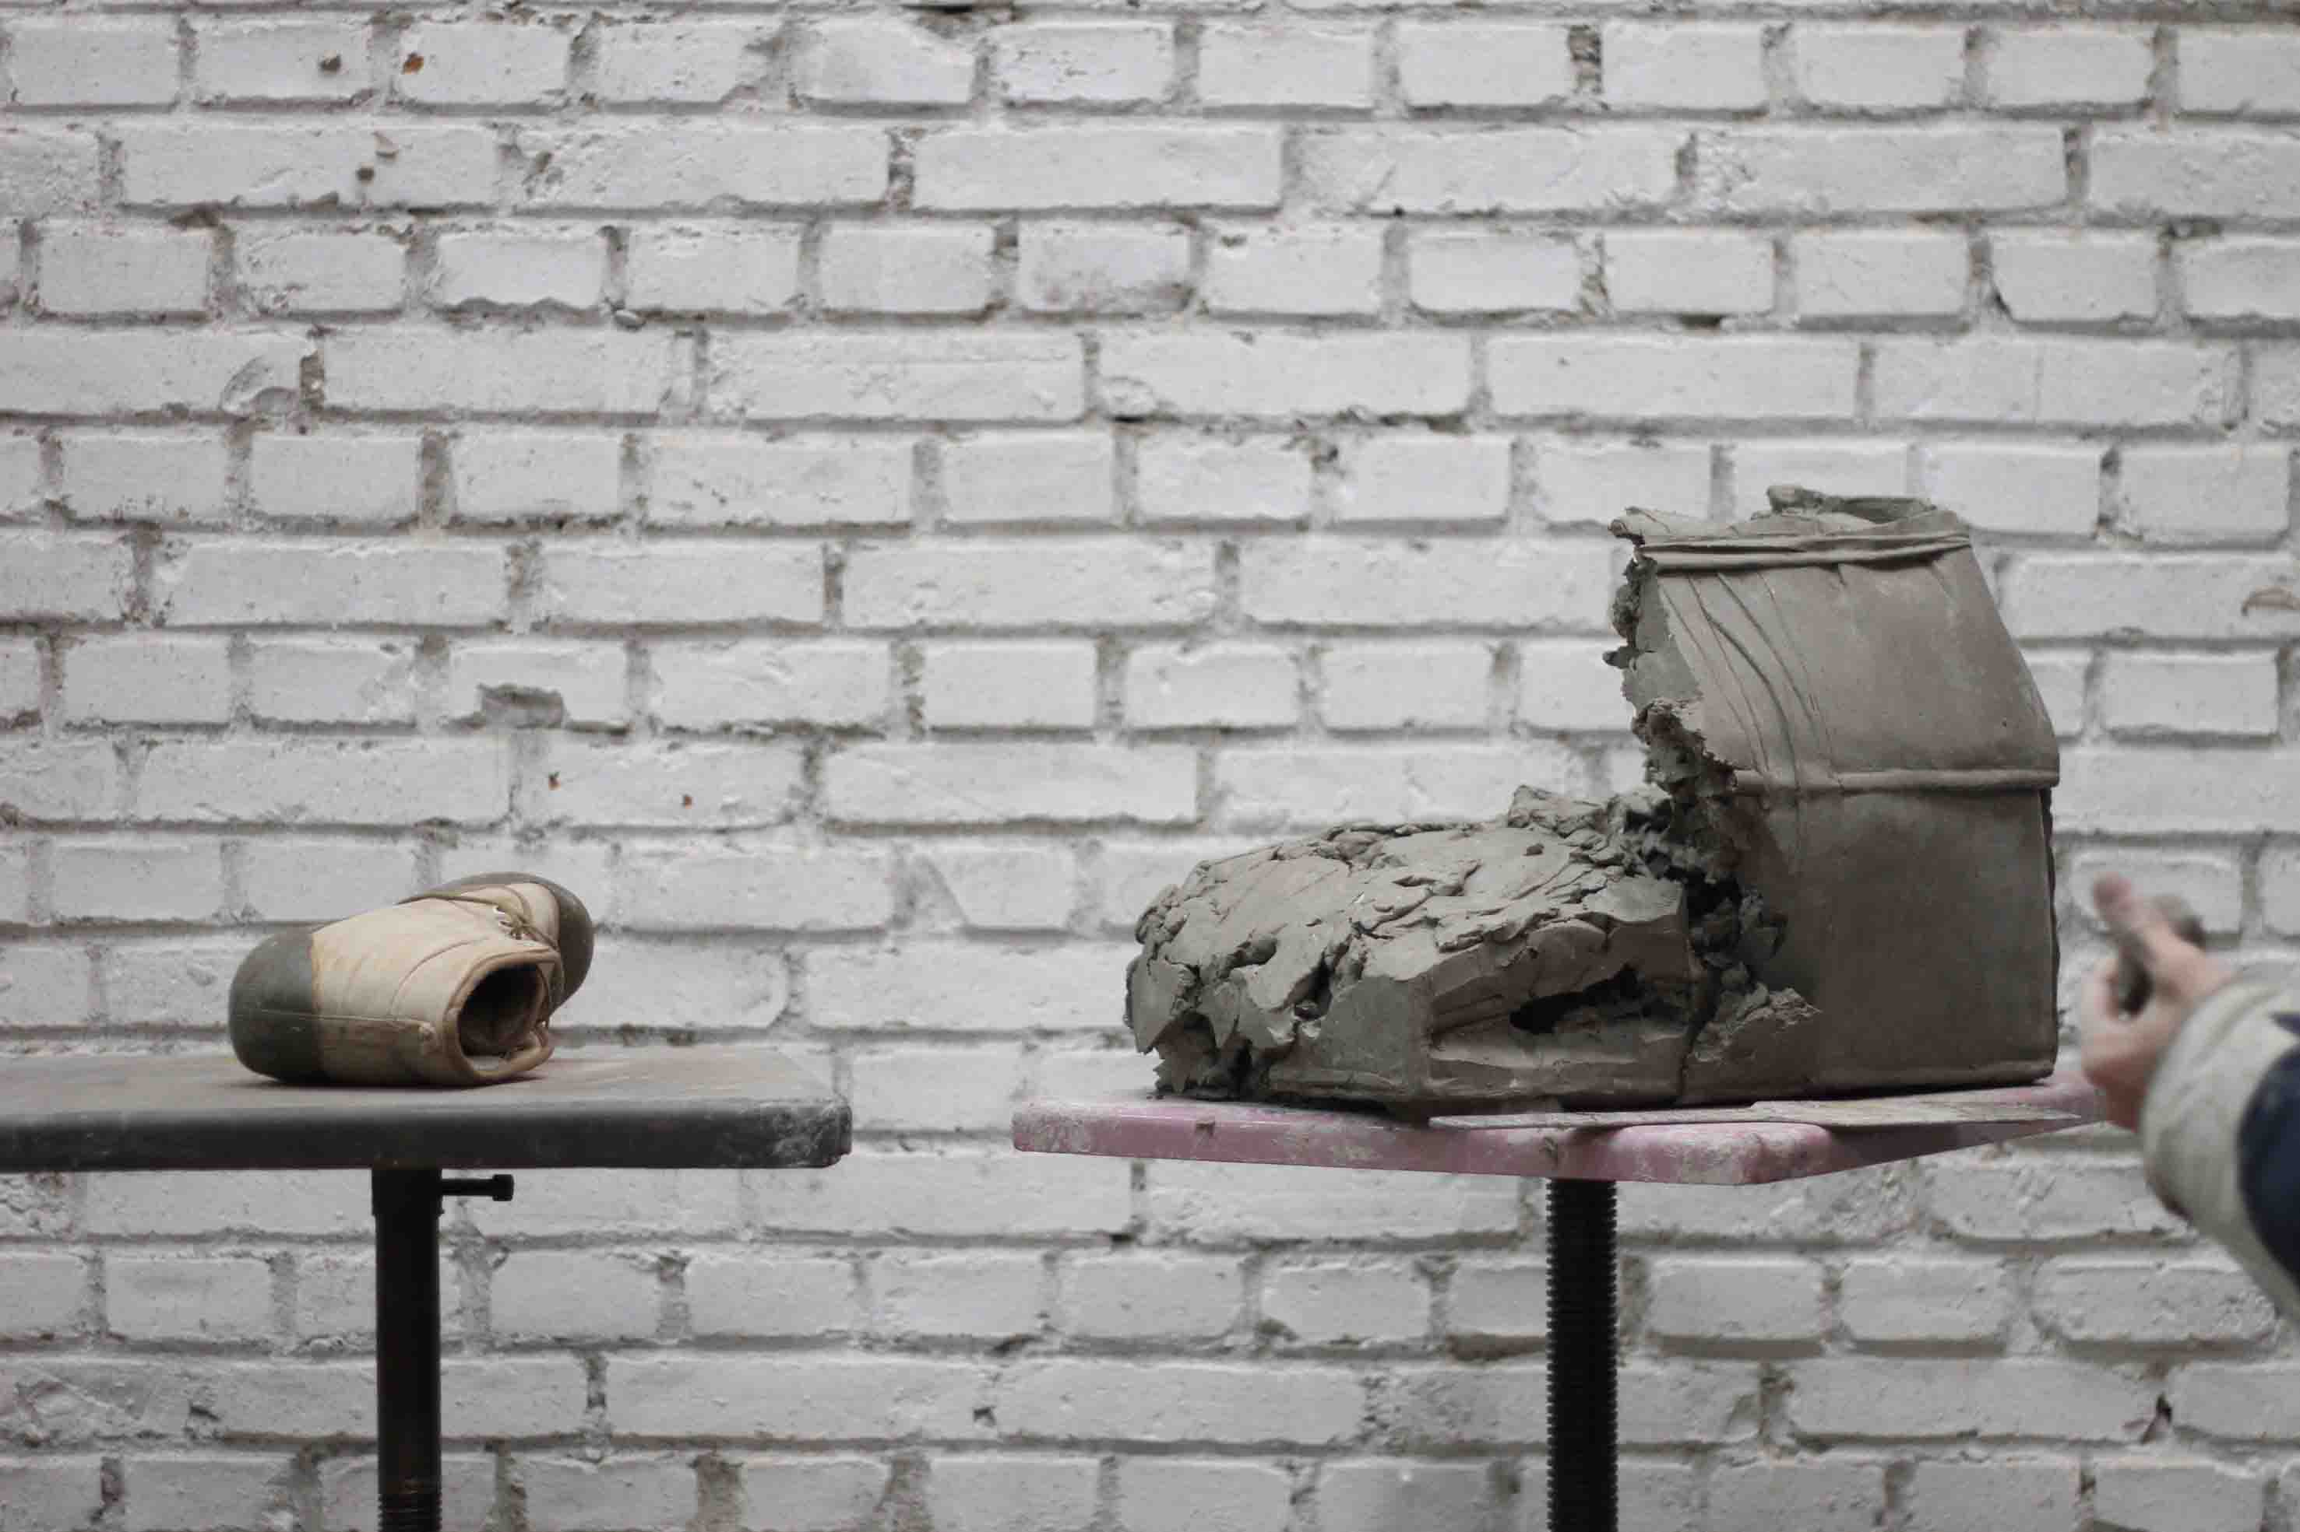

《一堆泥巴的故事，41－80》2010-2012，局部67#

*Narrative by a Pile of Clay* 41-80,2011-2012 (detail 67#)

32

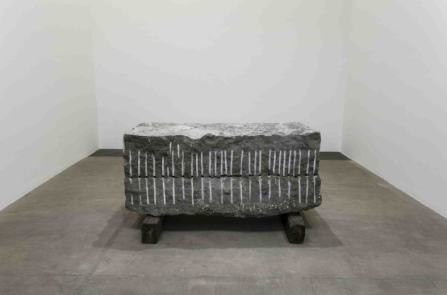

《记忆》 2012

青石，枕木  
青石两块, 分别为50×210×83 cm, 49×210×83 cm;  
枕木两块, 均为22×16×109 cm

物体诞生，侵占世界的一块空间，真实而实在；而所有物体又都会消逝，将已占有的空间还给这个世界，留下的只有影像和痕迹；随着影像和痕迹的消褪，就只留下了记忆。艺术家的已过世的启蒙老师董增山（1968--2009）的形象烙印在这整块青石里，而青石内部所留下的虚空的印痕里则存放着老师的灵魂与艺术家的记忆。

#### Memory, 2012

bluestones, railway sleepers  
two bluestones, sizes: 50 × 210 × 83 cm, 49 × 210 × 83 cm; two railway sleepers, each 22 × 16 × 109 cm

When something comes into being, it occupies a space in this world. This is true and therefore real, and yet all these things will also vanish, returning the place in the world they emerged from. All that’s left behind is an impression, a trace. When these images and traces fade away, then all that’s left is a memory. The impression of my late teacher (Dong Zengshan, 1968-2009) has been imprinted (in relief) into these blocks of bluestone, and his soul and my memories are stored in the hollowed out spaces.

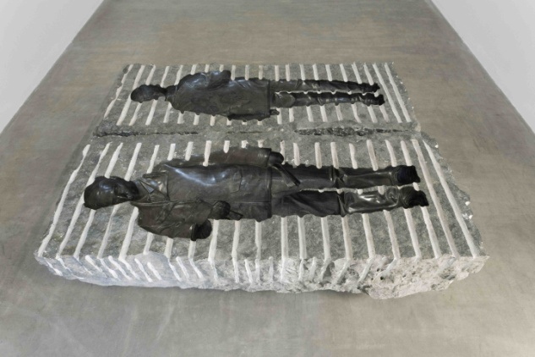

《记忆》 2012

青石，枕木  
青石两块, 分别为50×210×83 cm, 49×210×83 cm;  
枕木两块, 均为22×16×109 cm

#### Memory, 2012

bluestones, railway sleepers  
two bluestones, sizes: 50 × 210 × 83 cm, 49 × 210 × 83 cm; two railway sleepers, each 22 × 16 × 109 cm

33

《柴火》2012

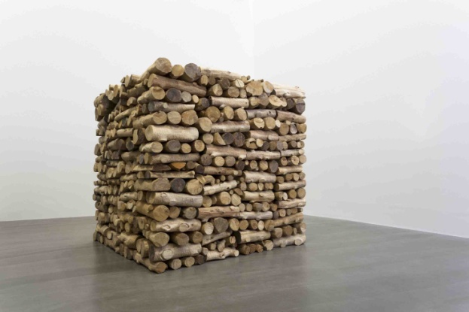

樟木

200 × 200 × 200 cm (8 m3)

Firewood, 2012

camphorwood

200× 200 × 200 cm (8 m3)

《柴火》2012

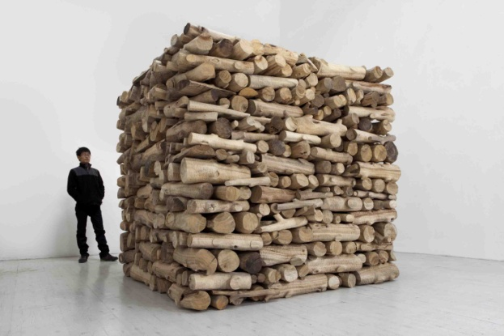

樟木

200 × 200 × 200 cm (8 m3)

Firewood, 2012

camphorwood

200× 200 × 200 cm (8 m3)

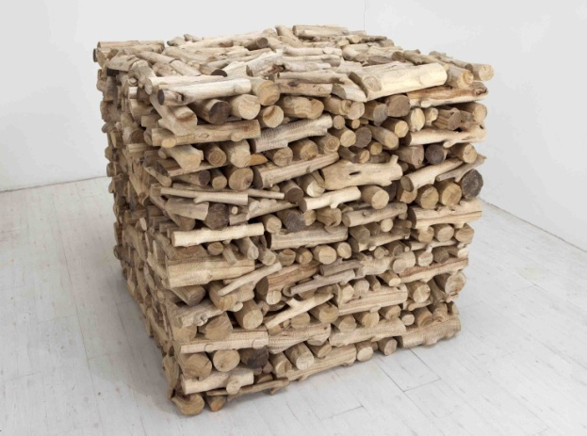

《柴火》2012

樟木

200 × 200 × 200 cm (8 m3)

Firewood, 2012

camphorwood

200× 200 × 200 cm (8 m3)

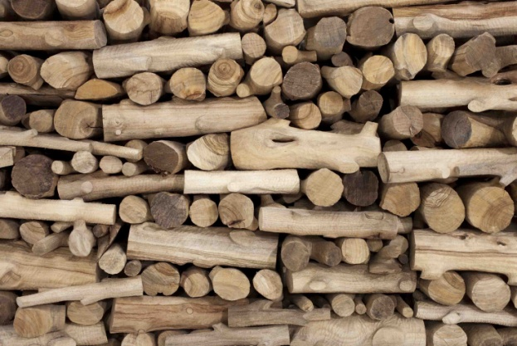

《柴火》2012,局部

Firewood, 2012（detail）

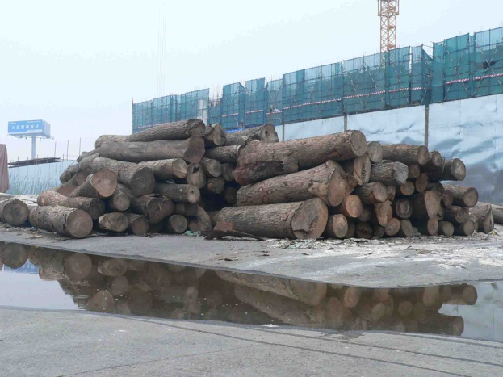

《柴火》制作过程，2012

Production Process ofFirewood*，*2012

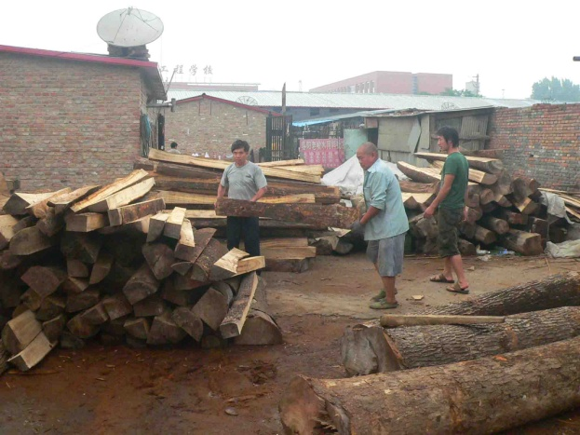

《柴火》制作过程，2012

Production Process ofFirewood*，*2012

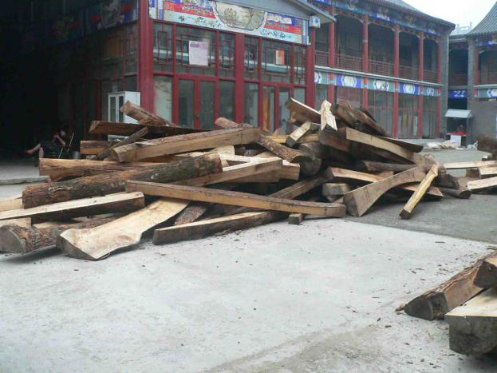

《柴火》制作过程，2012

Production Process ofFirewood*，*2012

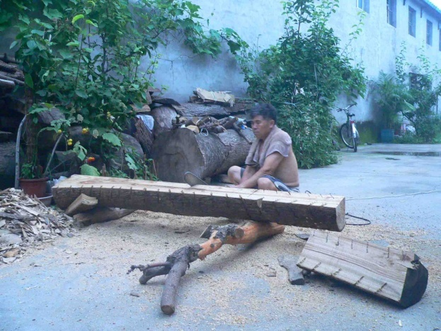

《柴火》制作过程，2012

Production Process ofFirewood*，*2012

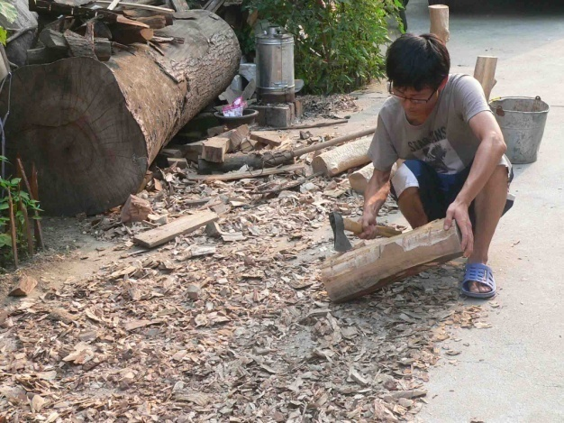

《柴火》制作过程，2012

Production Process ofFirewood*，*2012

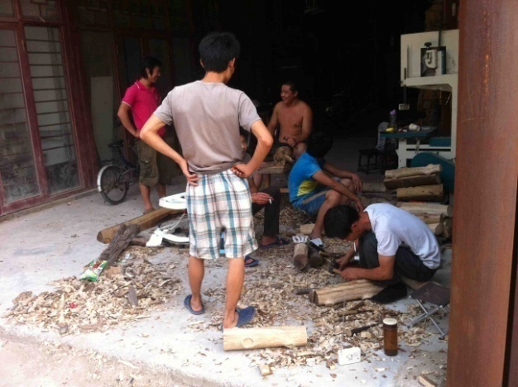

《柴火》制作过程，2012

Production Process ofFirewood*，*2012

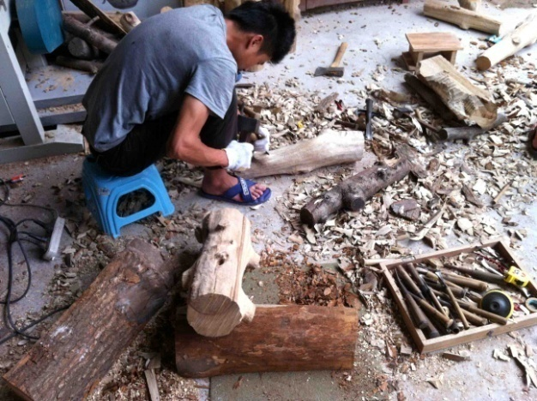

《柴火》制作过程，2012

Production Process ofFirewood*，*2012

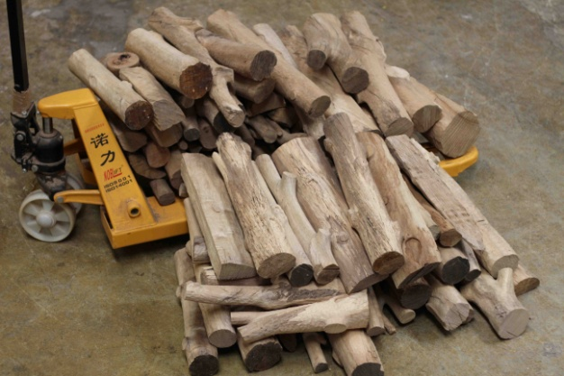

《柴火》制作过程，2012

Production Process ofFirewood*，*2012

34

#### 《一朵云彩－2012》2012

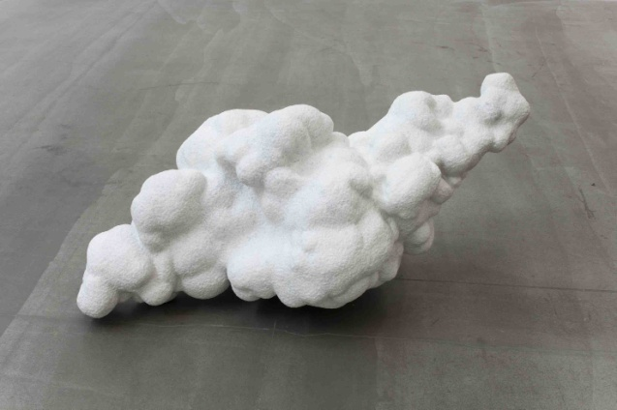

大理石  
45×96×55 cm

*Cloud - 2012,*2012

marble  
45 x 96 x 55 cm

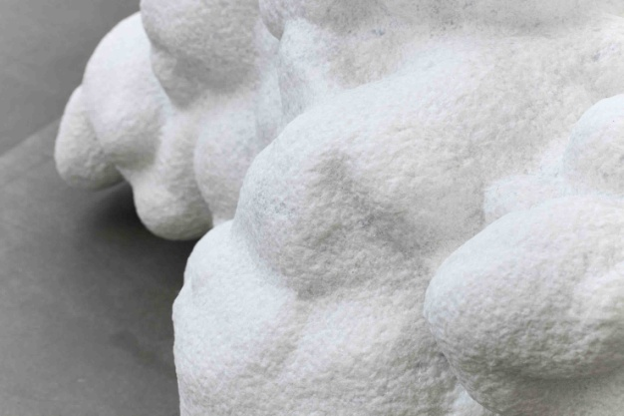

#### 《一朵云彩－2012》2012，局部

Cloud - 2012, 2012(detail)

35

#### 《金山》2012

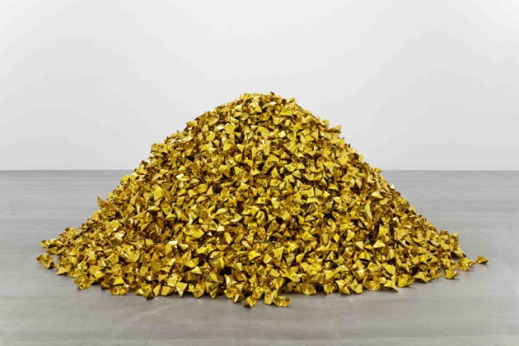

金纸  
100×230 cm

*Mountain of Gold,*2012

gold paper  
100 x 230 cm



#### 《金山》2012，局部

*Mountain of Gold,*2012 (detail)

36

《一卷格子布》2012

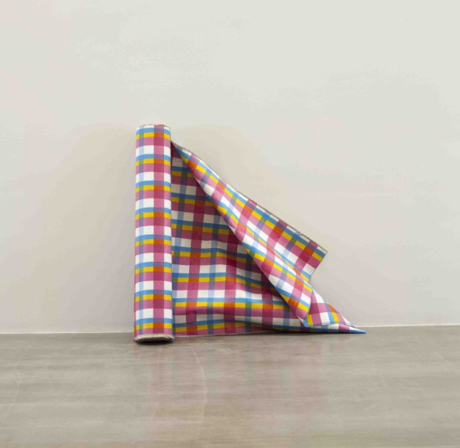

布面丙烯  
130×2950 cm

绘制在画布正反两面上的抽象图案既是两幅独立的抽象画，也相互印证使得这卷布成为对日常之物的戏仿。

#### 

#### A Roll of Plaid Cloth, 2012

acrylic on canvas  
 130 x 2950 cm

The abstract designs rendered on both

sides of the canvas are pieces of

abstract art and also their mutual

corroboration turns this roll of fabric

into a parody of an everyday object.

《一卷格子布》2012

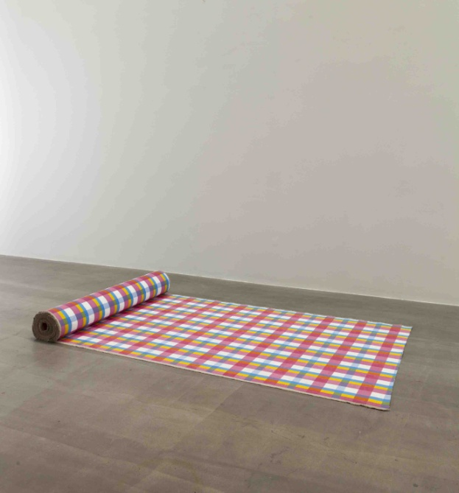

布面丙烯  
130×2950 cm

#### 

#### A Roll of Plaid Cloth, 2012

acrylic on canvas  
 130 x 2950 cm

37

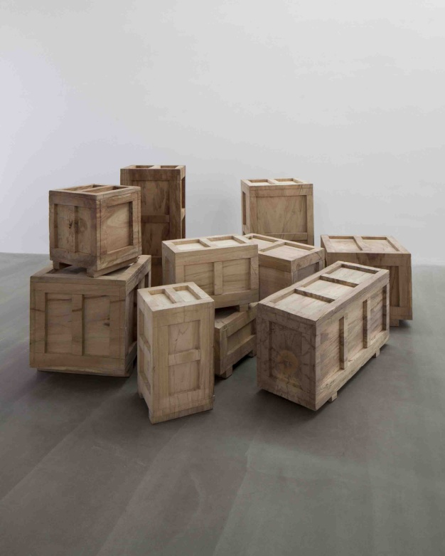

#### 《十件雕塑》2011 - 2012

樟木  
共10件，尺寸不等

作品是十件随意摆放的“包装箱”，每一个都是用整块樟木雕刻而成的实心箱子。箱子的这一介质让它回避了雕塑的具体形象，透过箱子的形状和大小你只能大概估测里面“雕塑”的大致尺寸，除此一无所知。当然你也可以把它理解为：每个包装箱里面装着一件雕塑，这些雕塑可以是你能想象出来的任何形象（状）。

The Ten Sculptures, 2011 - 2012

camphorwood  
10 pieces, different sizes

The artwork consists of ten randomly positioned "crate", each one is a solid crate carved from a single block of camphorwood. By using these boxes we avoid having a sculpture with a specific form. The only thing you can know about this sculpture is a rough estimate of the "sculpture's" interior dimensions from each box's shape and size. Of course you can also interpret them as having a sculpture inside each box, and these sculptures can have any shape you care to imagine.

#### 《十件雕塑》2011 - 2012，局部

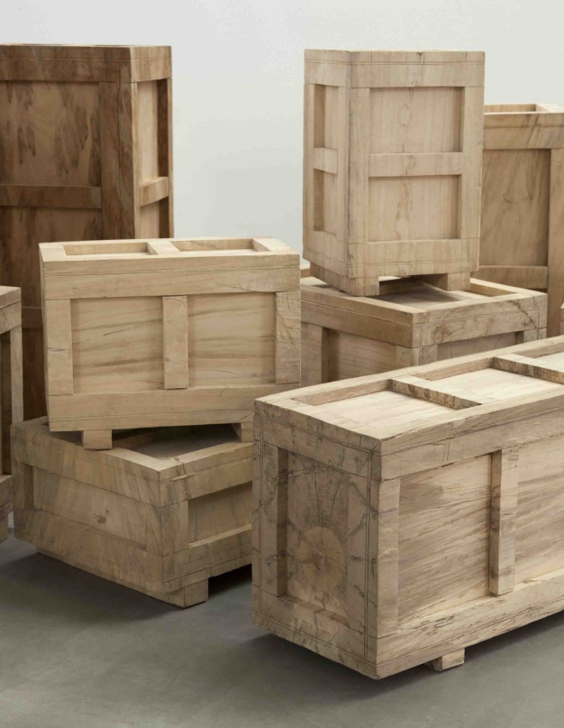

The Ten Sculptures, 2011 - 2012 (detail)

38

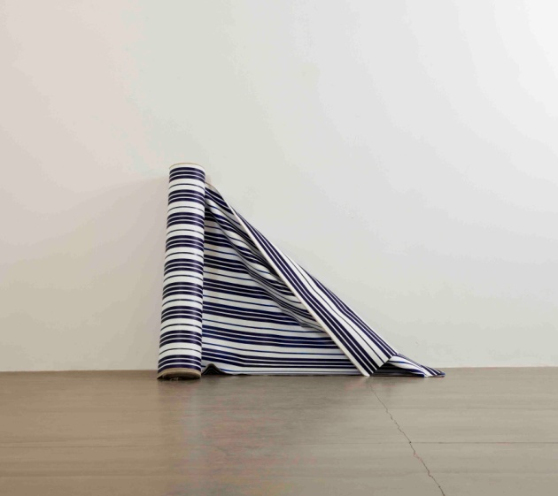

《一卷蓝白条布》2012

布面丙烯  
120×2950 cm

绘制在画布正反两面上的抽象图案既是两幅独立的抽象画，也相互印证使得这卷布成为对日常之物的戏仿。

#### A Roll of Blue White Striped Cloth, 2012

acrylic on canvas  
120 x 2950 cm

The abstract designs rendered on both sides of the canvas are pieces of abstract art and also their mutual corroboration turns this roll of fabric into a parody of an everyday object.

39

#### 《∞》2011 - 2012

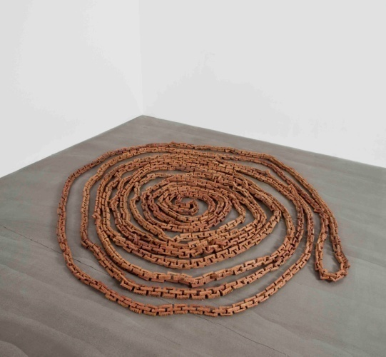

红酸枝木  
ø 250 cm （尺寸可变，可呈现不同形态）

∞, 2011 - 2012

siam rosewood  
ø 250 cm (size varies; different forms of presentation)

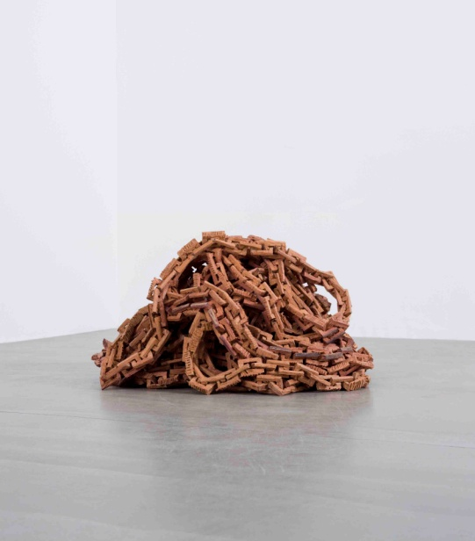

#### 《∞》2011 - 2012

红酸枝木  
ø 250 cm （尺寸可变，可呈现不同形态）

∞, 2011 - 2012

siam rosewood  
ø 250 cm (size varies; different forms of presentation)

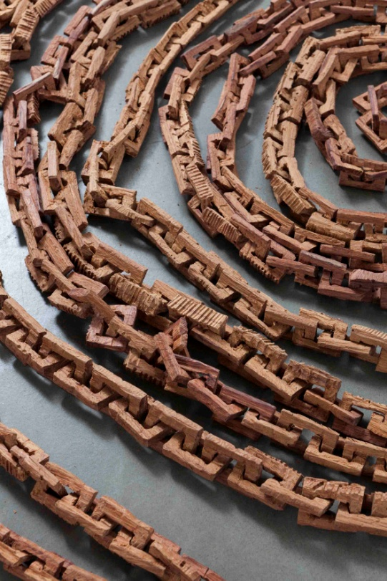

#### 《∞》2011 - 2012，局部

∞, 2011 - 2012(detail)

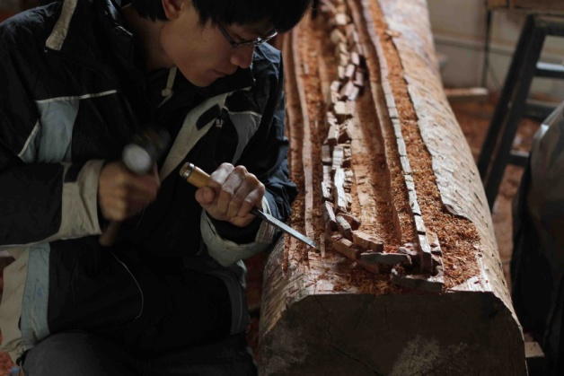

《∞》制作过程，2011 - 2012

#### Production Process of ∞，2011 - 2012

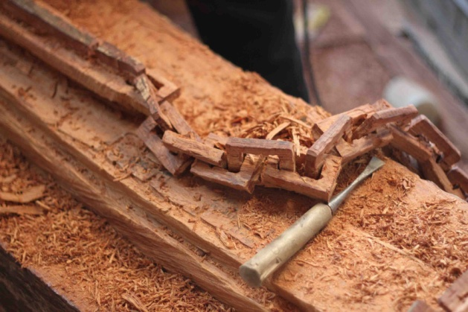

《∞》制作过程，2011 - 2012

Production Process of ∞，2011 - 2012

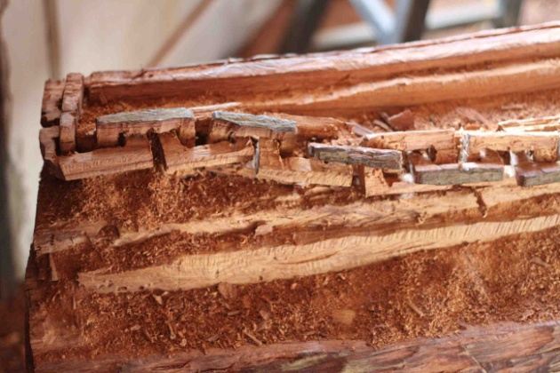

《∞》制作过程，2011 - 2012

Production Process of ∞，2011 - 2012

40

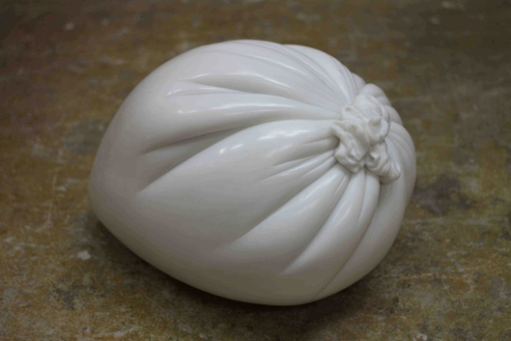

《一口气—鲁贝尔家族肖像》 2011

大理石

36×40×50cm

《一口气——鲁贝尔家族肖像》是鲁贝尔家族的雕像。

一直以来，雕像通常是对人物外部形象的呈现。在这里，艺术家则把视点从被塑造对象的外部转移到身体内部，将身体内部的空间通过吹气（一口气）的方式转移到塑料袋当中，并以此为模型将其打制成大理石材质。那么这块大理石的体积就是对身体内部空间的客观塑造与呈现。而这个装着家族成员各自一口气的形象饱满、材质坚硬的大理石 “塑料袋”是艺术家对鲁贝尔家族肖像的描绘与呈现。

中国有句古语“人活一口气”，艺术家则通过一口气来呈现一个家族。

One Breath—Portrait of the Rubell Family

marble

36×40×50cm

One Breath -- Portrait of the Rubell Family is a sculpture of the Rubell family.

For a very long time, sculptures have tried to show the model's outside appearance. Here, I have shifted the viewpoint from depicting the outside appearance of the models to their inner appearances. I transferred the space in their bodies into a plastic bag by having them blow into it (just one breath from each person), and I used the bag as a model to make the marble sculpture. Thus, the volume of this marble is an objective recreation and representation of the spaces in their bodies. And this full-figured, solid marble "plastic bag" filled with one full breath from each of the members of the Rubell family is my depiction and representation of the portrait of the Rubell family.

There's an old saying in Chinese that goes, "Man lives just for one breath," and I use one breath to portray a family.

《一口气—鲁贝尔家族肖像》制作过程，2011

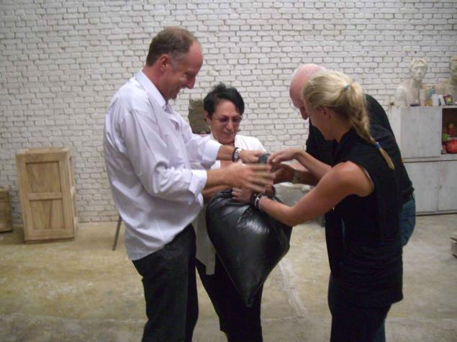

Production Process of One Breath—Portrait of the Rubell Family

#### *，*2011

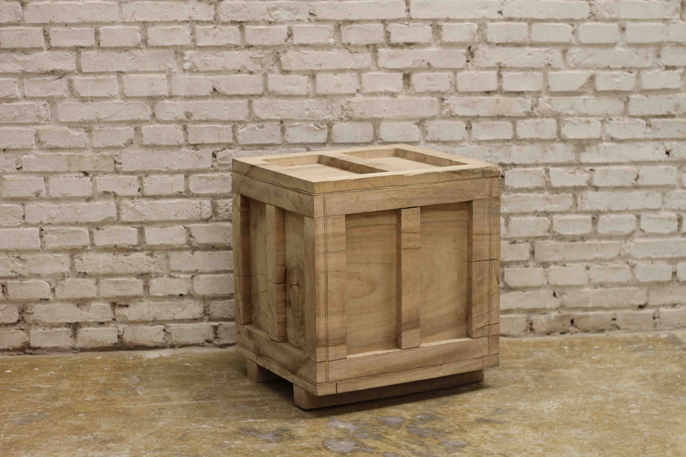

《那件雕塑》2011

樟木

尺寸待定

That Sculptures, 2011

camphorwood

尺寸待定

42

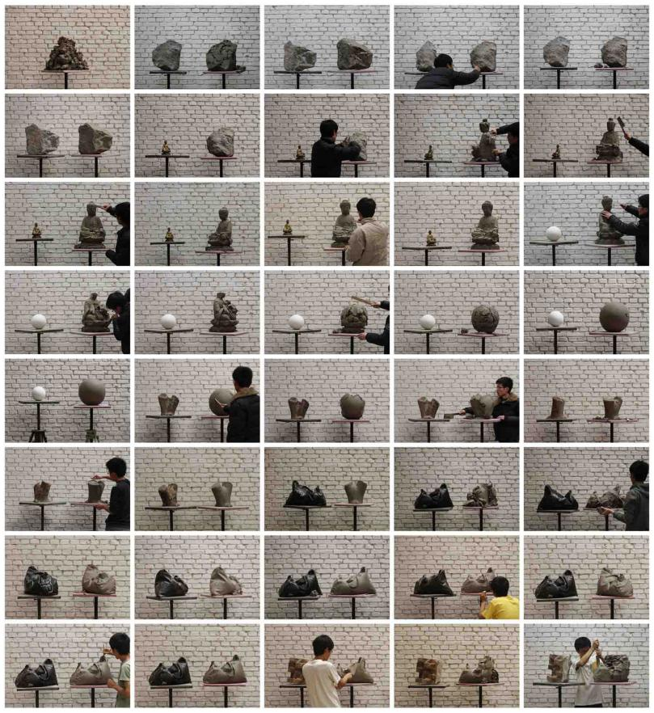

#### 《一堆泥巴的故事，1－40》2010-2011

c-print  
40张图片, 每张尺寸20×30 cm

“他是一个行者，用雕塑行走。从一个物体走向另一个物体。

像苦行僧，也像造物主————不收获什么，不到达雕塑，永远在路上。”

唐尧

Narrative by a Pile of Clay 1-40*,*2010-2011

c-print  
set of 40 photos, each 20×30 cm

"He is unwavering, never stopping; sculpture is his path, walking from one object to the next. Like an ascetic monk, yet also like a god-----not gaining anything, not reaching the sculpture, forever on the road."

Tang Yao

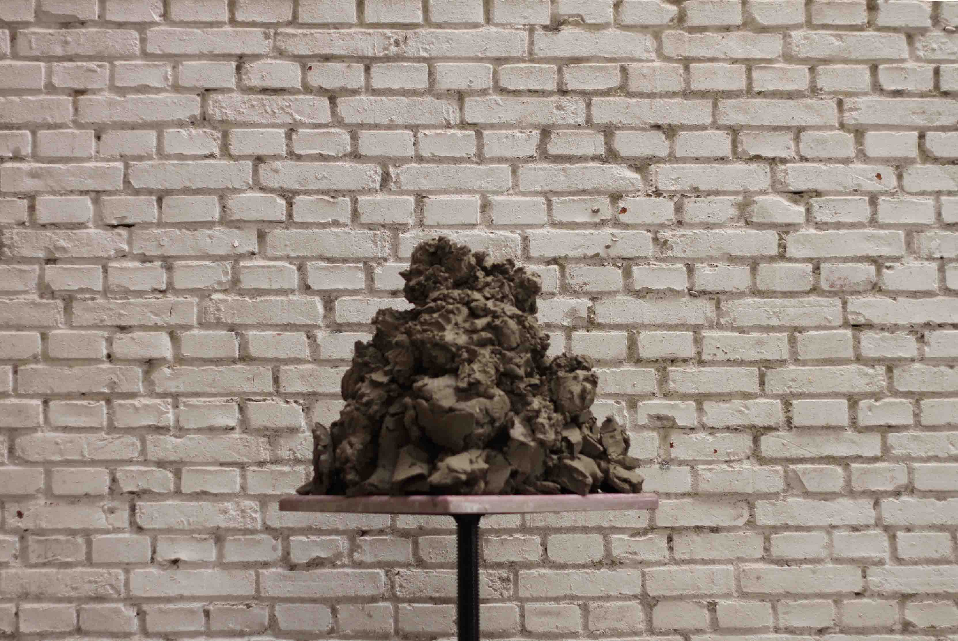

《一堆泥巴的故事，1－40》2010-2011，局部1#

Narrative by a Pile of Clay 1-40*,*2010-2011 (detail 1#)

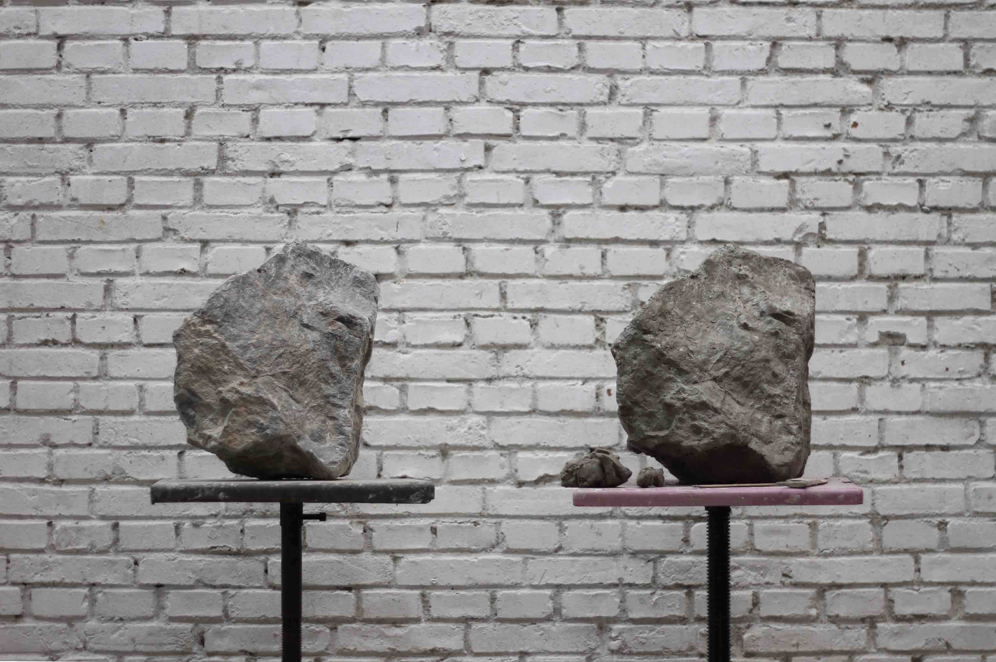

《一堆泥巴的故事，1－40》2010-2011，局部5#

Narrative by a Pile of Clay 1-40*,*2010-2011 (detail 5#)

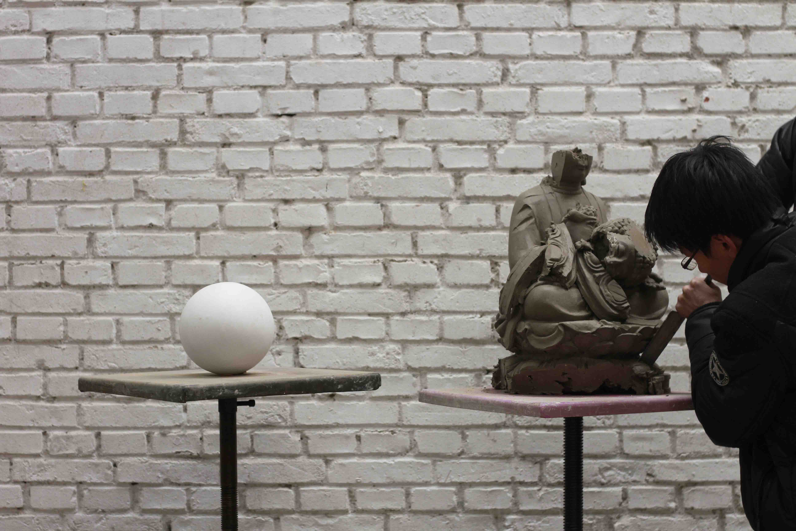

《一堆泥巴的故事，1－40》2010-2011，局部16#

Narrative by a Pile of Clay 1-40*,*2010-2011 (detail 16#)

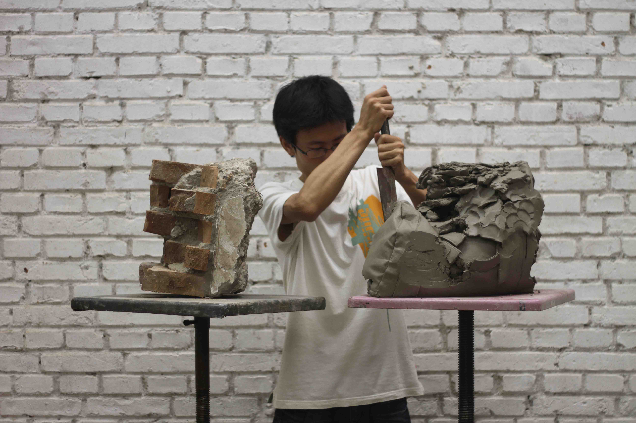

《一堆泥巴的故事，1－40》2010-2011，局部40#

Narrative by a Pile of Clay 1-40*,*2010-2011 (detail 40#)

43

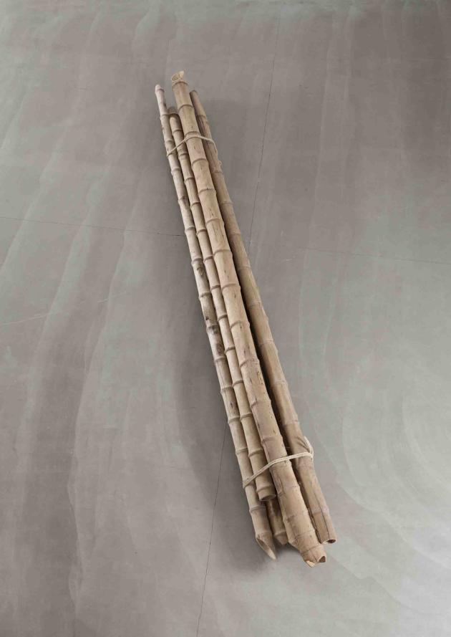

《一捆竹竿, No. 2》2011

金丝楠木旧房梁, 麻绳,   
8 根竹竿为一捆; 每根直径10-15 cm,   
长330-470 cm

#### A Bundle of Bamboo, No. 2, 2011

jinsi nanmu wood from old house beam, hemp rope  
8 pcs; each ø 10-15 cm,   
length 330-470 cm

44

《一捆竹竿, No. 1》2011

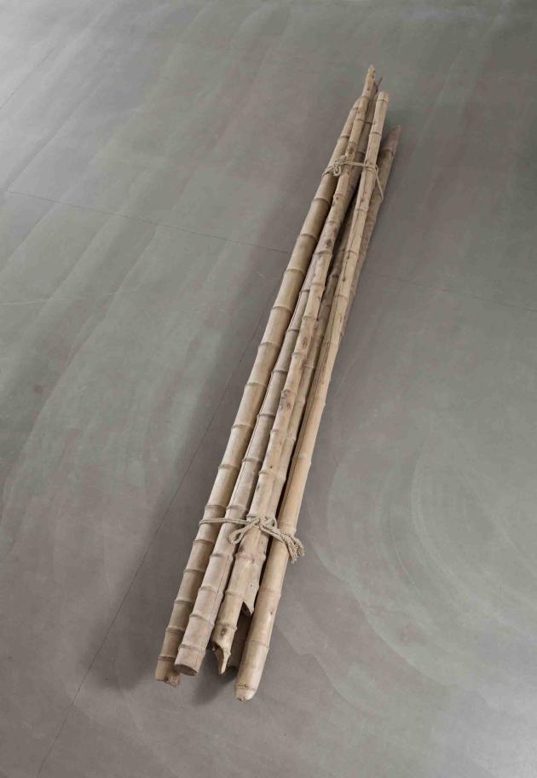

金丝楠木旧房梁, 麻绳,   
8 根竹竿为一捆; 每根直径10-15 cm,   
长330-470 cm

#### A Bundle of Bamboo, No. 1, 2011

jinsi nanmu wood from old house beam, hemp rope  
8 pcs; each ø 10-15 cm,   
length 330-470 cm

45

《一根竹竿, No. 1》2011

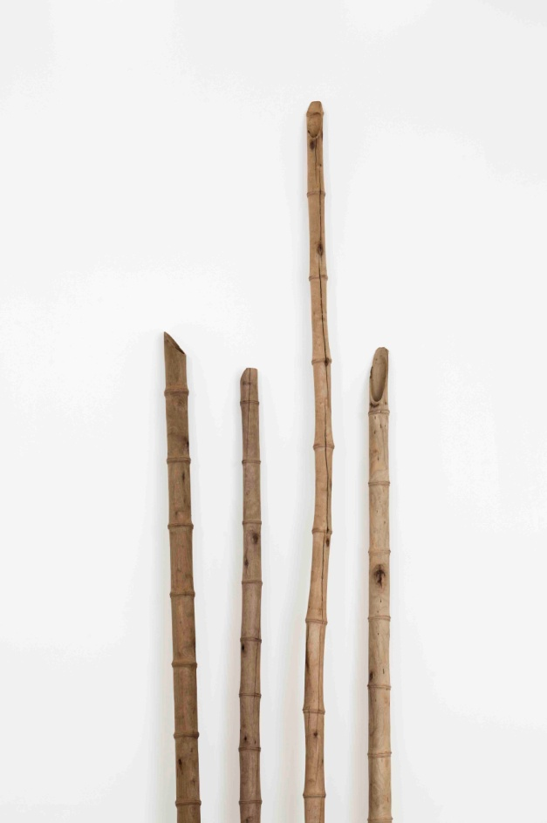

《一根竹竿, No. 2》2011

《一根竹竿, No. 3》2011

《一根竹竿, No. 4》2011

金丝楠木旧房梁

每根ø 10-15 cm，长度350-450 cm

A Stick of Bamboo, No. 1, 2011  
A Stick of Bamboo, No. 2, 2011  
A Stick of Bamboo, No. 3, 2011  
A Stick of Bamboo, No. 4, 2011

jinsi nanmu wood from old house beams   
each ø 10-15 cm, length 350-450 cm

以下4张图放在 作品局部 的分类里

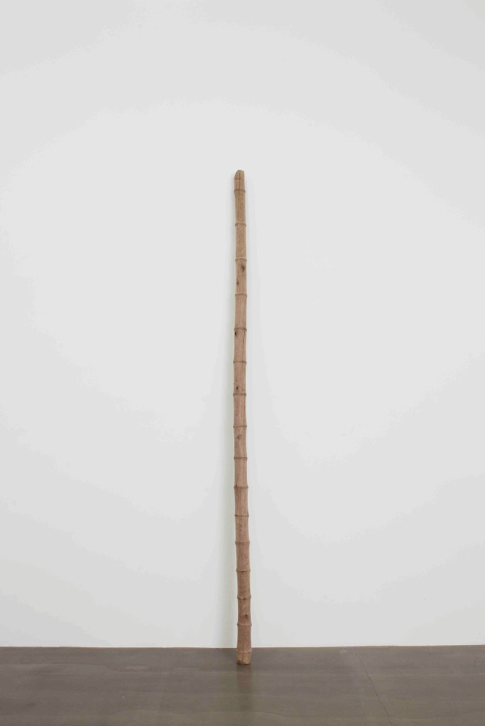

《一根竹竿, No. 1》2011

A Stick of Bamboo, No. 1, 2011

《一根竹竿, No. 2》2011

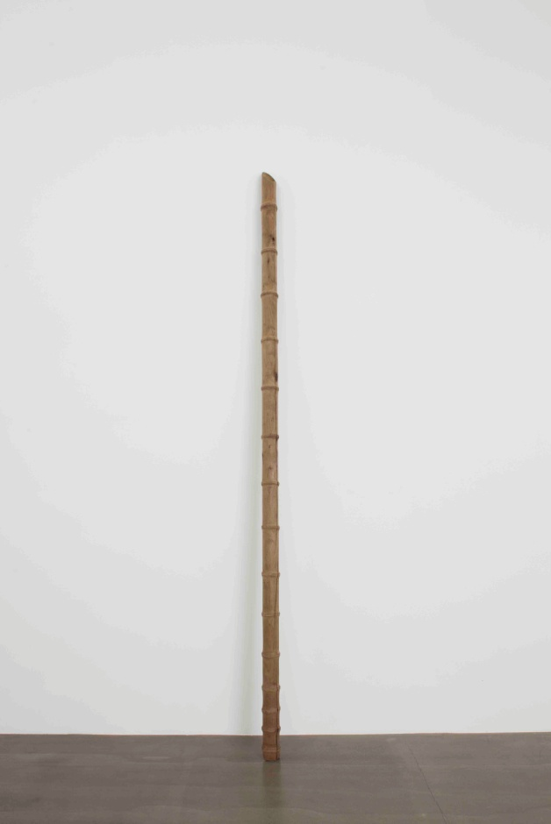

A Stick of Bamboo, No. 2, 2011

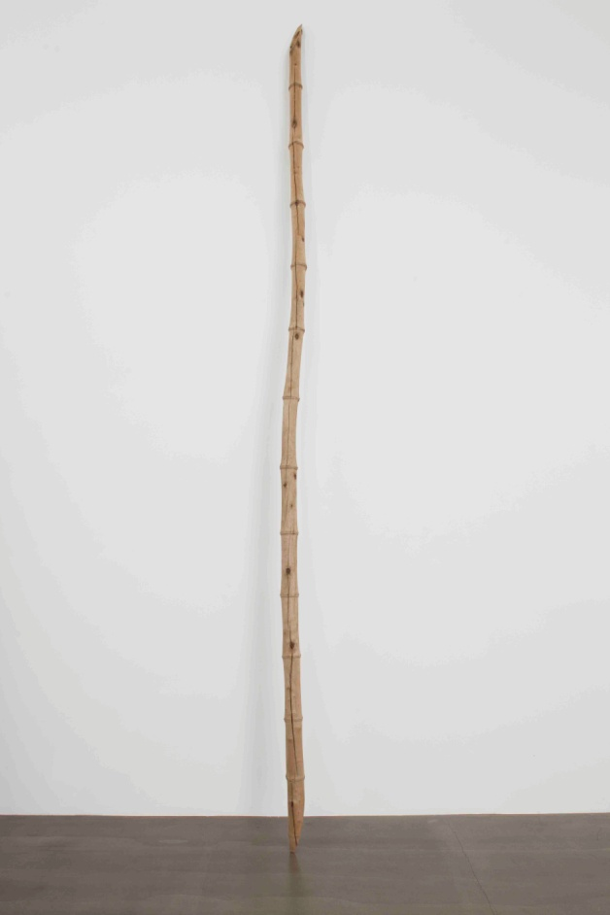

《一根竹竿, No. 3》2011

A Stick of Bamboo, No. 3, 2011

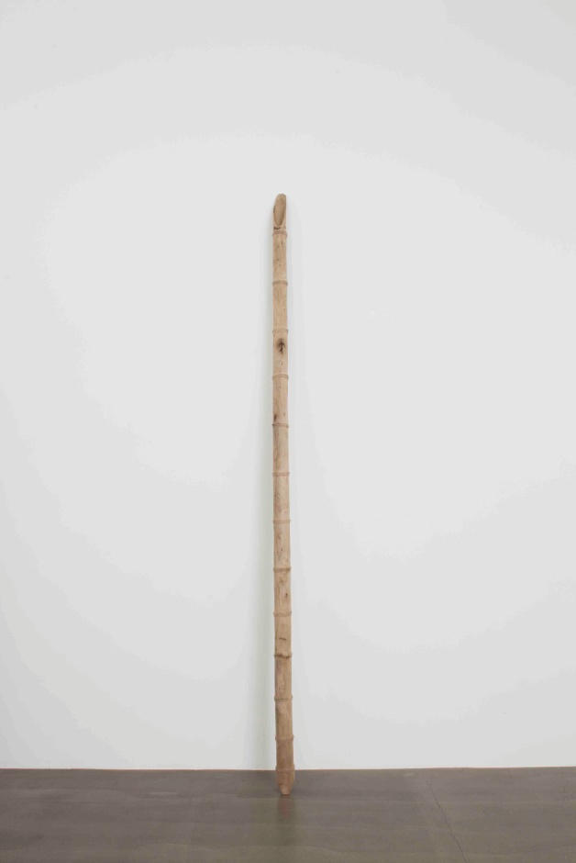

《一根竹竿, No. 4》2011

A Stick of Bamboo, No. 4, 2011

下面的图片放在制作过程里

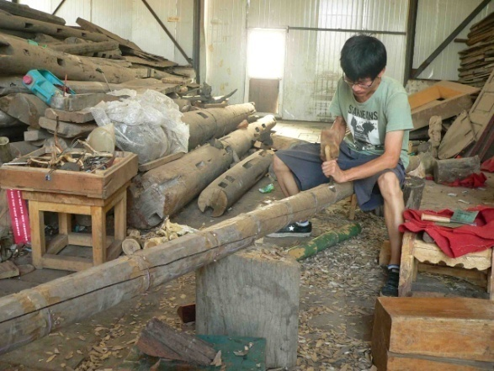

《一根竹竿, No. 4》制作过程，2011

*Production Process of* A Stick of Bamboo, 2011

46

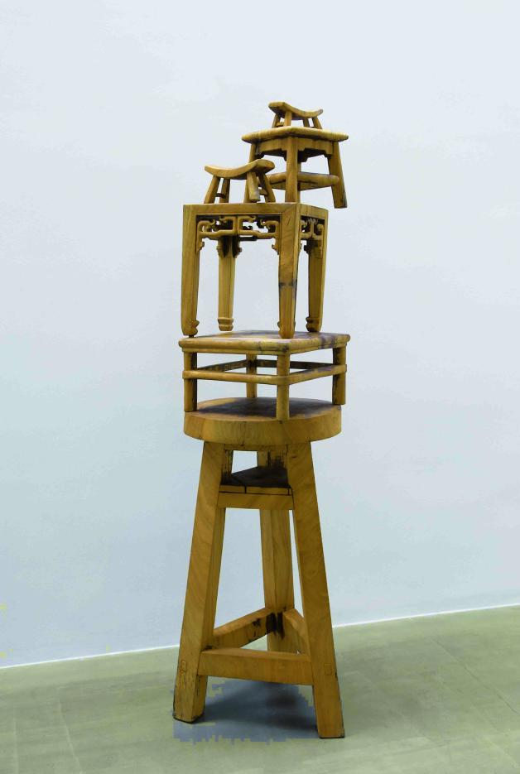

《木塔，No. 2》2011

樟木  
199×65×65 cm

#### Wood Pagoda, No.2,2011

camphorwood  
199×65×65 cm

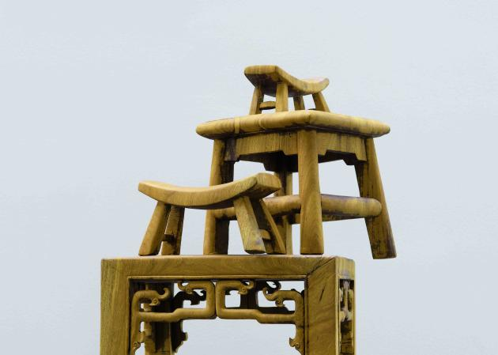

《木塔，No. 2》2011，局部

#### Wood Pagoda, No.2,2011 (detail)

《木塔，No. 2》制作过程，2011

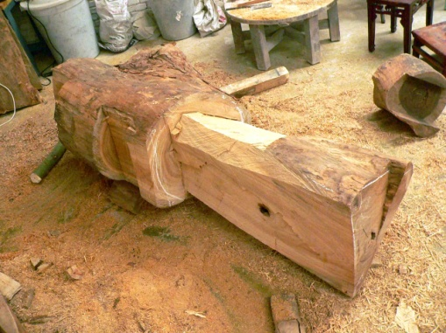

#### Production Process of Wood Pagoda,No.2, 2011

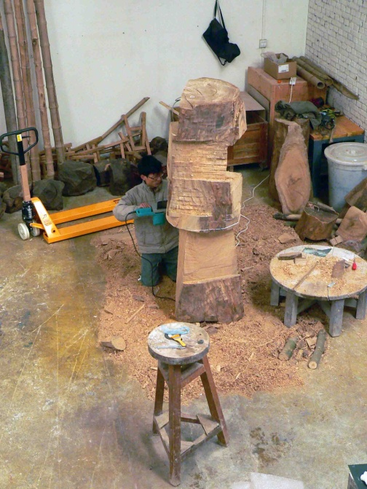

《木塔，No. 2》制作过程，2011

#### Production Process of Wood Pagoda,No.2, 2011

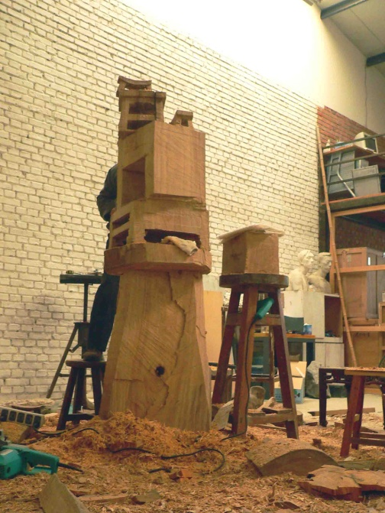

《木塔，No. 2》制作过程，2011

#### Production Process of Wood Pagoda,No.2, 2011

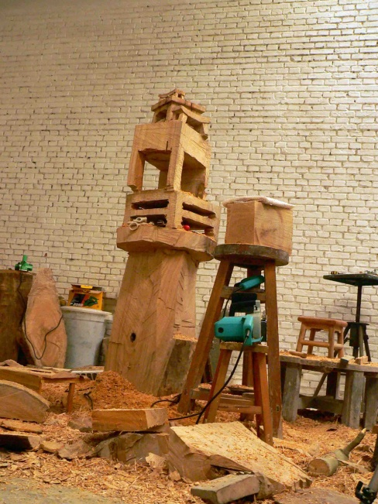

《木塔，No. 2》制作过程，2011

#### Production Process of Wood Pagoda,No.2, 2011

47

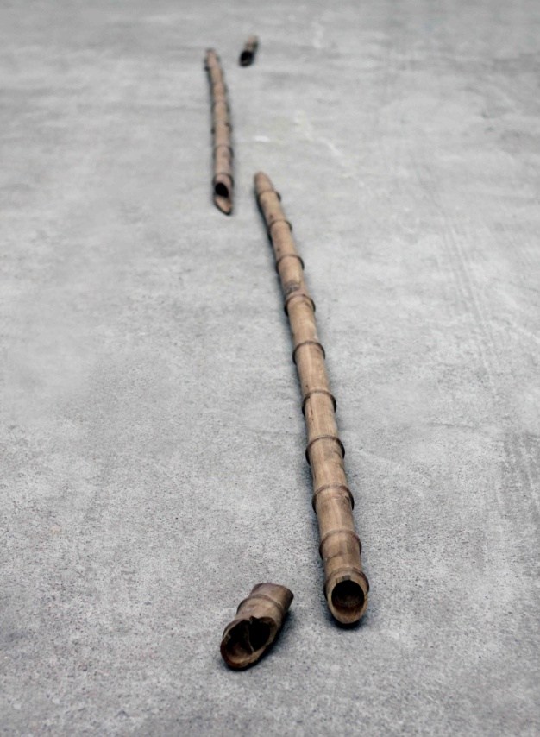

《一根竹竿》2011

金丝楠木旧房梁

4件，分别为300 × ø 7 cm, 286 × ø 7 cm, 78 × ø 7 cm, 23 × ø 7 cm

A Stick of Bamboo, 2011

jinsinanmu wood from old house beams

4 pieces, 300 × ø 7 cm, 286 × ø 7 cm, 78 × ø 7 cm, 23 × ø 7 cm

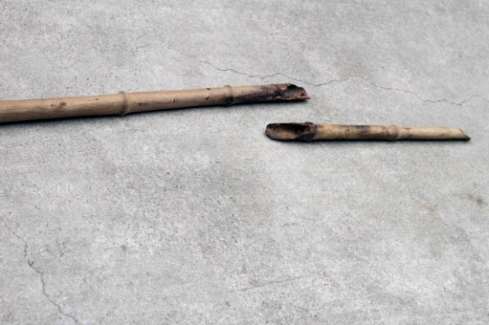

《一根竹竿》2011，局部

A Stick of Bamboo, 2011 (detail)

48

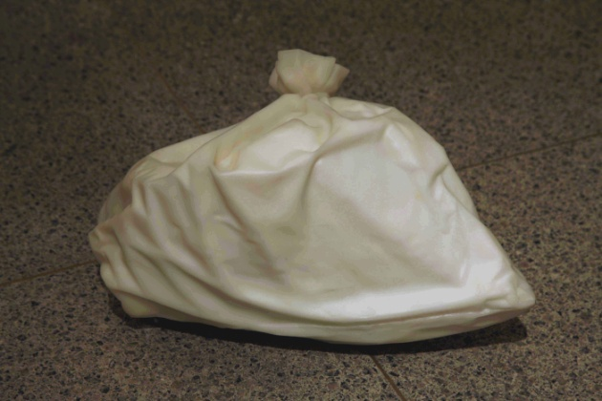

《自塑像—我的一口气》2010

汉白玉

22×35×25cm

《一口气》是一个肖像系列作品，但并不刻画人的相貌。相反，它将每个所刻画人物的身体内部的空间（肺活量）加以捕捉并呈现出来。艺术家让他们向塑料袋吹一口气，并将其转化为大理石雕塑。《自塑像——我的一口气》是艺术家为自己所做的塑像，也是该系列的第一件。

The Portrait of Myself—My Breath

marble

22×35×25cm

One Breath is a series of portraits that are not actual likenesses of the people portrayed. Instead, it makes it possible to see the amount of breath each person can hold. The artist asks the people he is depicting to exhale once into a plastic bag. He then translates the bag into a marble sculpture.

49

《局部练习》2010

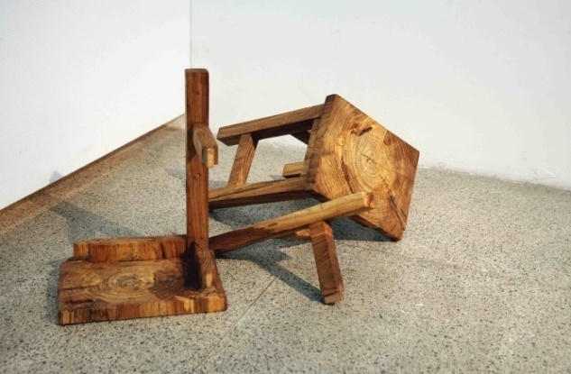

榆木

3件，尺寸不等

Partial Research,2010

elm

3 pieces, different sizes

50

《我的十一只板凳》2009-2010

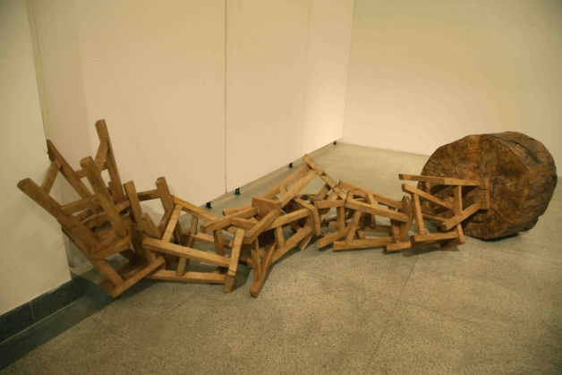

木

70×80×360cm

Eleven Wooden Square Stools，2009-2010

wood

70×80×360cm

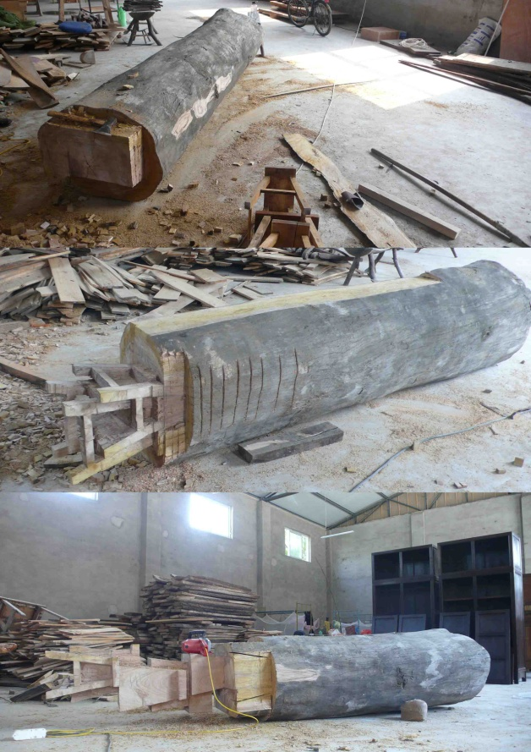

《我的十一只板凳》制作过程，2009-2010

#### Production Process ofEleven Wooden Square Stools*，*2009-2010

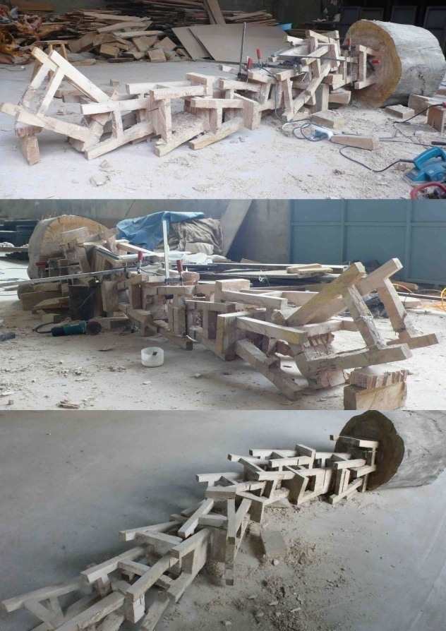

《我的十一只板凳》制作过程，2009-2010

#### *Production Process of* Eleven Wooden Square Stools*，*2009-2010

51

《木塔》2010

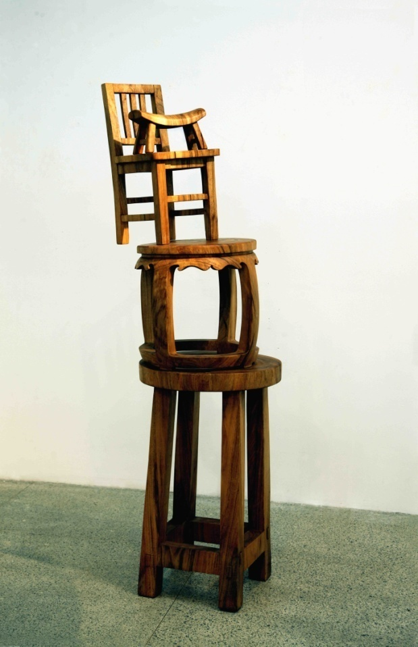

樟木

165×60×50cm

*Wood Pagoda，*2010

camphorwood

165×60×50cm

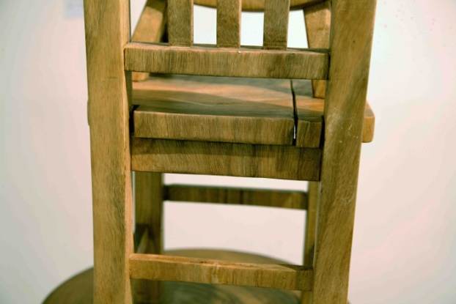

《木塔》2010，局部

Wood Pagoda，2010 (detail)

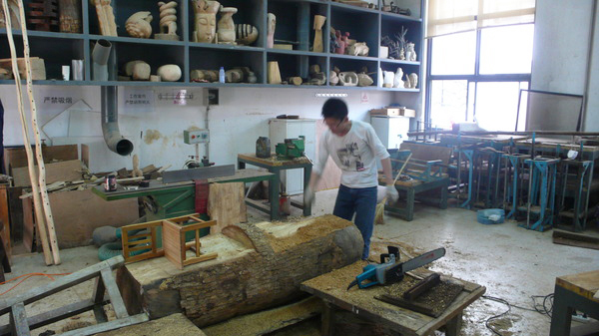

《木塔》制作过程，2010

#### *Production Process of Wood Pagoda，*2010

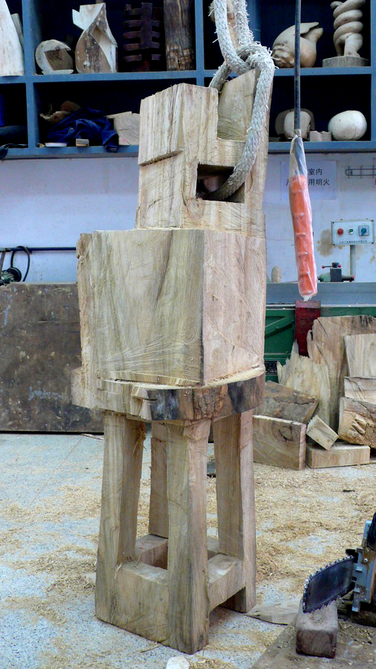

《木塔》制作过程，2010

#### *Production Process of Wood Pagoda，*2010

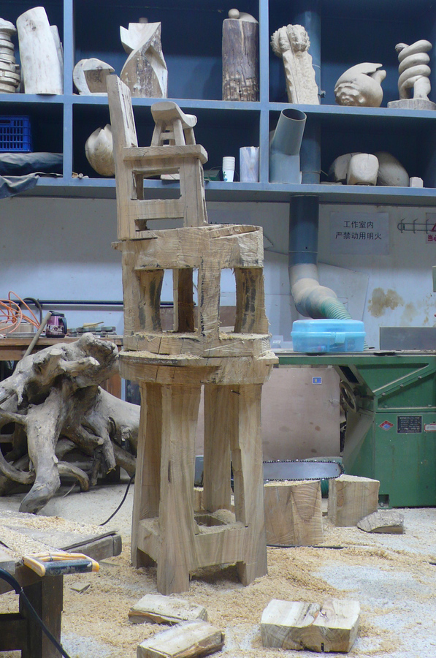

《木塔》制作过程，2010

#### *Production Process of Wood Pagoda，*2010

52

《兄弟》2010

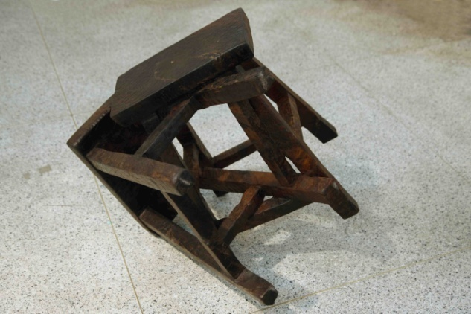

鸡翅木

（尺寸待定）

Brother, 2010

Wenge

（尺寸待定）

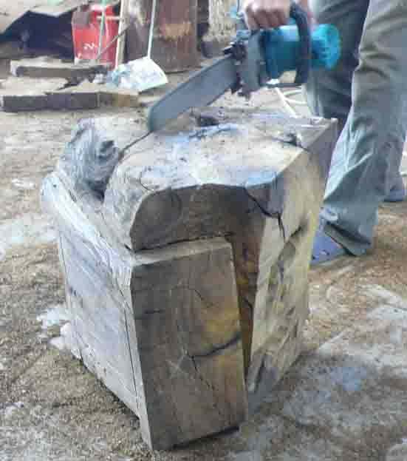

《兄弟》制作过程，2010

Production Process ofBrother*，*2010

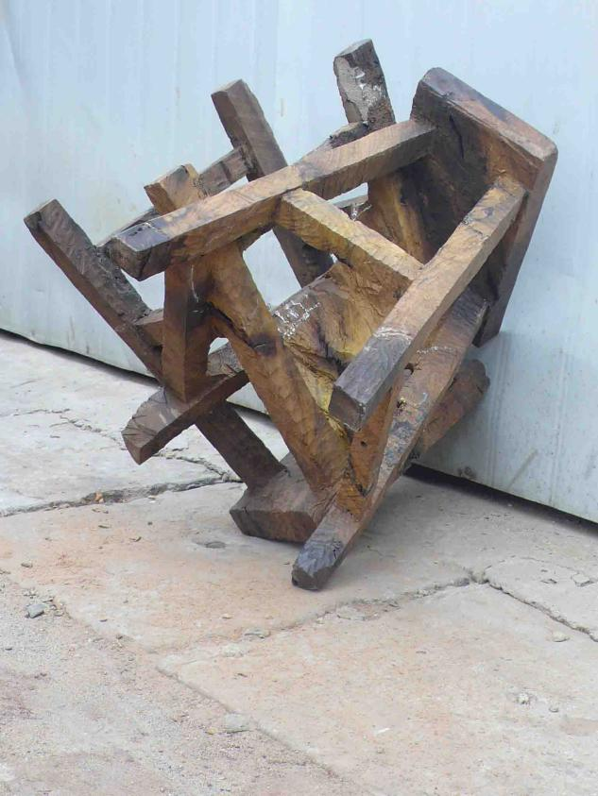

《兄弟》制作过程，2010

Production Process ofBrother*，*2010

53

《板凳肖像》2010

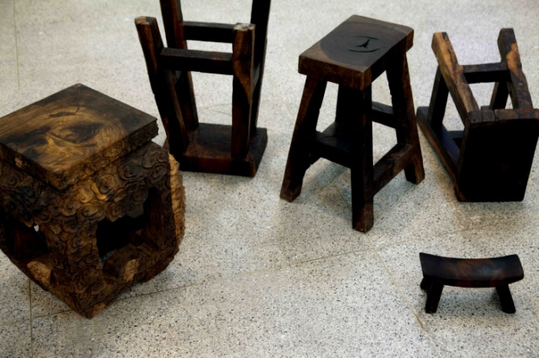

鸡翅木

共5件，尺寸不等

The Portrait of Stools,2010

wenge

5 pieces, different sizes

《板凳肖像》制作过程，2010

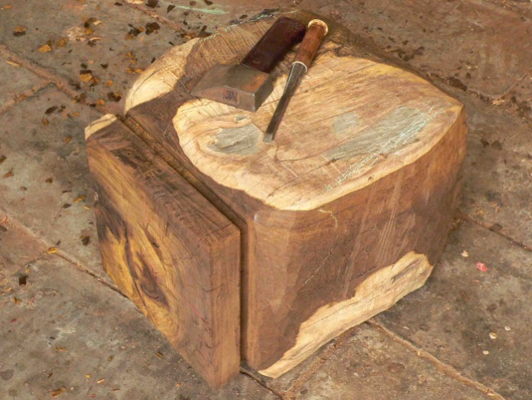

#### Production Process ofThe Portrait of Stools*，*2010

54

《模仿的故事》2008-2010

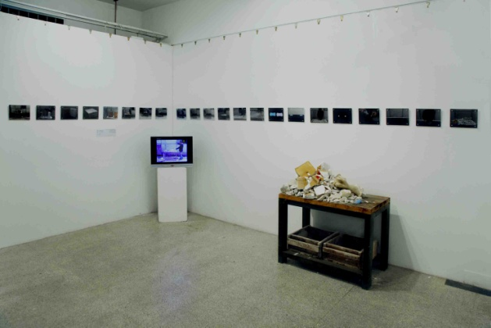

混合媒体（大理石残块，图片，影像）

可变尺寸

意大利文艺复兴时期的巨匠米开朗基罗曾经这样形容雕塑家的工作：雕塑家所要做的工作，只是将自己从一块岩石中所看到的形体解放出来而已。

胡庆雁的作品《模仿的故事》，向观众展示了一件石雕作品被从另一件石雕作品里打制出来的连续不断的过程。

他是从一块白色的大理石开始这个过程的。

胡庆雁先是从这块白色大理石中看到了一个包装箱，于是他动手将多余的部分去掉，甚至将包装箱的表面细节完全模仿到位，然后表面着色。作为一件写实雕刻看起来它已经完成了，但是在作者的观念中，这只是一个重新开始的前提而已。

接下来，作者找到了一块牛的腿骨来作为下一步雕刻工作的模仿对象。大理石雕刻成的包装箱被破为数块，其中一块被打制得跟那块腿骨一模一样，而且也被着上色。

第三个被模仿的对象是一块天蓝色的香皂，于是大理石雕刻的腿骨又被打破而其中一块变成了那块香皂。

随后，一个骰子成为下一个被模仿的对象。然后是一粒黄豆，这可能是雕塑家所能模仿的最小的对象了。然而这粒大理石黄豆还是被粉碎成为了一小撮面粉状的事物。至此，胡庆雁才宣告讲完了自己模仿的故事。

作为胡庆雁的毕业作品，它展示的是一系列打制过程的图片，以及一大堆打制模仿过程所剩下的大大小小的大理石碎块。从其中一些石块表面残留的不同颜色上，观众依稀能够分辨出他们所曾经组成的那些个形状。

一块石头被从小到大打制成不同形状的被模仿物品，直至化为粉末的过程，正是胡庆雁作品的完整过程。

胡庆雁将米开朗基罗的概念贯彻到了极限，他不停顿地从一个物体中看出其中所蕴含的另一个物体，并一次次地将它们陆续从前一个物体中解放出来。最终，这整个过程演化为一个艺术家思维与心理上修行的过程。

-----------隋建国

**The Story of Imitation, 2008 – 2010**

mixed media (marble chips, photos, video)

varying sizes

《模仿的故事》2008-2010,大理石残块

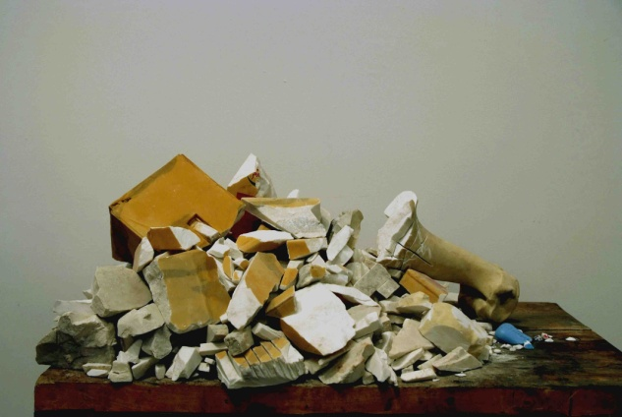

The Story of Imitation, 2008 – 2010(marble chips）

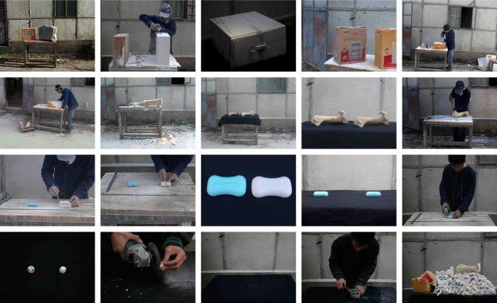

《模仿的故事》2008-2010,图片

The Story of Imitation, 2008 – 2010(photos）

55

**《养金鱼的男人》2008**

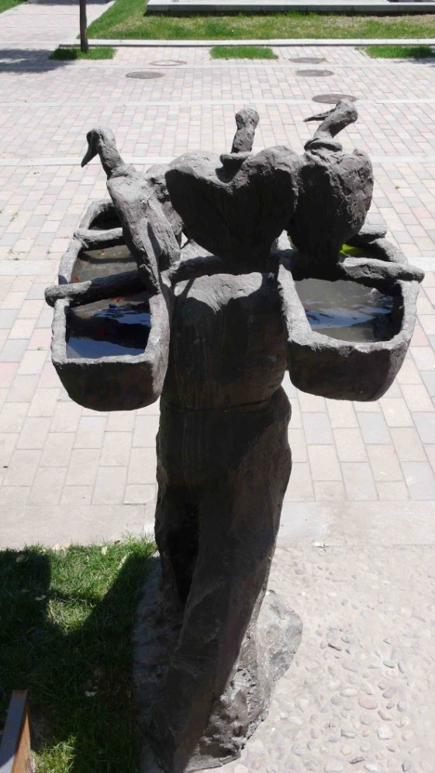

现成品雕塑（刘士铭先生的铸铜雕塑《架鱼鹰的男人》），金鱼，水

等人大小

艺术家直接借用刘士铭先生的铸铜雕塑《架鱼鹰的男人》，将两个空篓装满水，并放养金鱼。他人的雕塑作品和养在篓子里的金鱼组合成为一件新的作品《养金鱼的男人》。

**Old Fisherman,2008**

readymade sculpture,goldfish,water

life-size

**《养金鱼的男人》**2008**，局部**

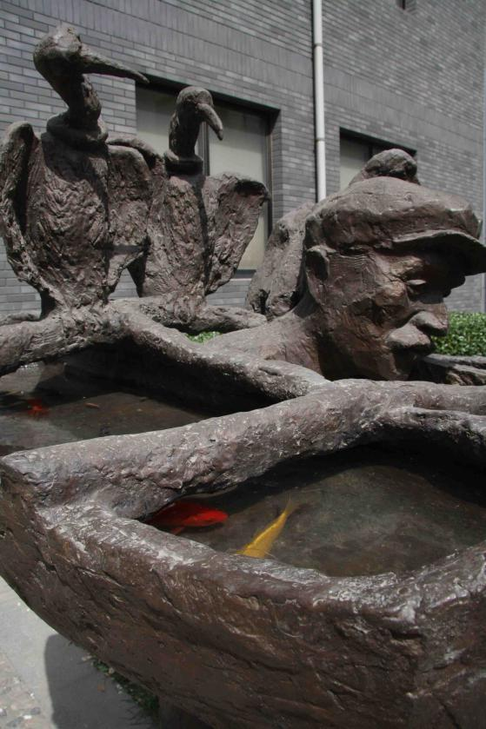

**Old Fisherman,2008 (detail)**

56

《脂肪楼梯》2006

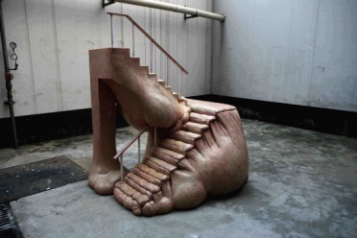

玻璃钢着色

180 × 150 × 150cm

Fat Staircase, 2006

painted fiberglass

180 × 150 × 150cm

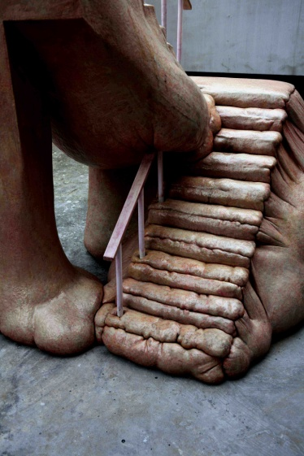

《脂肪楼梯》2006，局部

Fat Staircase, 2006 (detail)

57

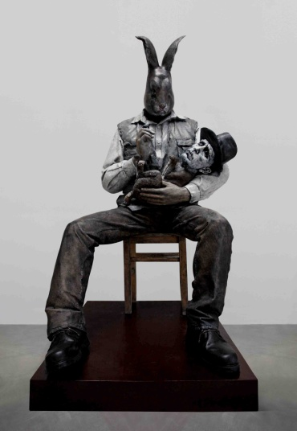

《对话：“我”对博伊斯解释艺术（图画）》2006

玻璃钢着色

160 × 91 × 73cm

“Dialogue: ‘I’ Explained Art (Picture) to Joseph Beuys” 2006

painted fiberglass

160 × 91 × 73cm